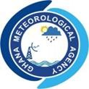
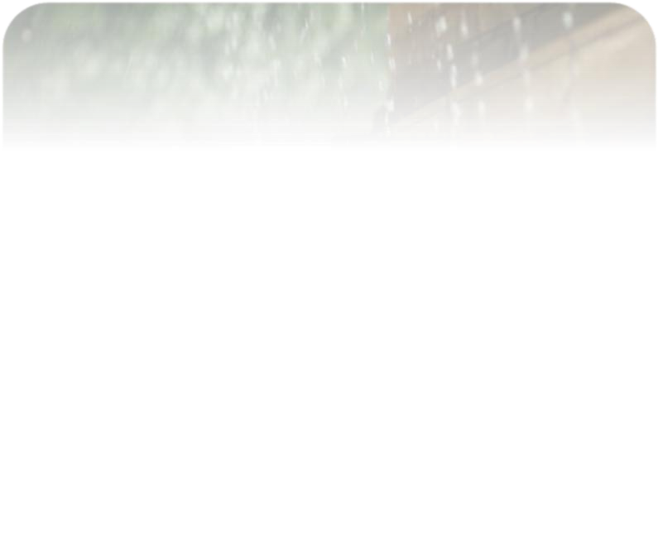
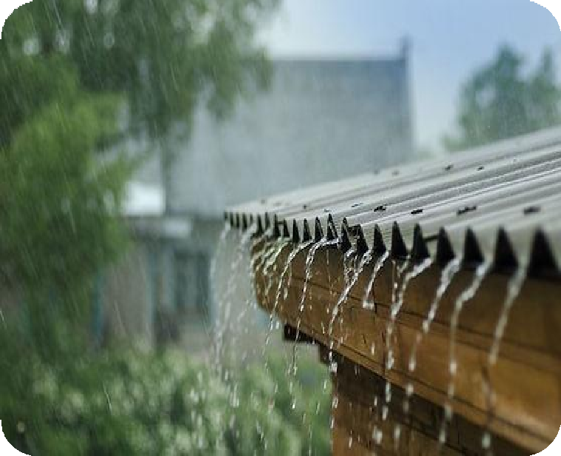


AUGUST 2026
CLIMATE BULLETIN

DEKAD 2, AUGUST (11-20)
GMET/CLIMATE/110826 FORM338
8/11/2026

Contents
SUMMARY 2
OBSERVED CLIMATE DRIVERS 3
Intertropical Front 3
1.0 RAINFALL AND TEMPERATURE DISTRIBUTION 6
1.1 Rainfall 6
1.2 Temperature 8
2.0 RAINFALL AND TEMPERATURE OUTLOOK 21ST AUGUST – 3RD SEPTEMBER 2026 10
3.0 ADVISORIES 11
1. Health Sector 11
2. Water Resources Management Sector 11
3. General Public 11
4.0 APPENDIX 12
4.1 Table of Stations 12

LIST OF FIGURES

Figure 1. Current MJO position as of August 1st Dekad, 2026……………………………..6

Figure 2a: Total Rainfall August 1st Dekad, 2026……………………………………………7

Figure 2b: Rainy Days August 1st Dekad, 2026……………………………………………..7

Figure 3: Rainfall Anomaly For August 1st Dekad, 2026…………………………………..8

Figure 4a. Maximum Temperature August 1st Dekad, 2026………………………………9

Figure 4b. Maximum Temperature Anomaly August 1st Dekad, 2026……………………9

Figure 5a. Minimum Temperature August 1st Dekad, 2026……………………………….10

Figure 5b. Minimum Temperature Anomaly August 1st Dekad, 2026……………………10

Figure 6. Max. And Min. Temperature Distribution For August 1st Dekad, 2026……..11

SUMMARY
- Rainfall:
  - Most areas received moderate to high rainfall, with several localised pockets exceeding 100 mm.
  - The highest rainfall totals (151.7 mm) were recorded around Kete Krachi in the transition zone.
  - Highest rainy days (up to 7 days) were recorded at around Kete Krachi, Elubo , Nkronza and Enchi.
- Rainfall Anomalies:
  - Surplus rainfall was recorded over most part of the country
  - Deficit rainfall concentrated in the west-central belt (Sunyani, Dormaa Ahenkro, Wenchi, Bui, Bole) and Kete Krachi.in transition belt
- Temperatures:
        - Maximum:
  - Highest maximum temperature of 31.5°C was recorded over Akuse
  - Coolest maximum temperatures 26.7°C, was recorded at Abetifi in the forest zone.
  - Maximum temperatures were below normal almost nationwide, with the largest deficits over Wa, Tamale and Kumasi. Accra and Tema experienced above normal day time temperatures.
Minimum:
  - The lowest minimum temperature of 20.9°C was recorded at Abetifi in the forest belt.
  - The highest minimum temperature of 24.5°C was recorded at Akuse and Axim.
  - Minimum temperatures were below normal across the entire country, with the most deficits over Wa, Bole, Sefwi Bekwai and Akim Oda.

OBSERVED CLIMATE DRIVERS

Intertropical Front
Also known as the Intertropical Convergence Zone (ITCZ) is a critical meteorological feature that significantly influences weather patterns in West Africa, including Ghana. The ITF is a boundary zone where the warm, moist air from the Atlantic Ocean (southwesterly monsoon winds) meets the hot, dry air from the Sahara Desert (northeasterly Harmattan winds). This convergence leads to the formation of clouds and precipitation, making it a key driver of the rainy season in West Africa. The northward movement of the ITF during March-July brings the rainy season to Ghana.

Between August 11 and 20, the Inter-Tropical Front (ITF) is assessed to have maintained a position similar to the previous dekad. The ITF was located at approximately 19.0N in the northern sector of Mali, marginally south of its position during the 1st dekad of August, consistent with the slow, near-stationary behaviour typical of the ITF at this stage of the monsoon season. Table 1 below shows the evolving ITF's position over Ghana, located between 5W and 5E, including the estimated 2nd dekad value.
DEKAD | 5W | 0 | 5E
January 1 | 10.7 | 9.0 | 6.6
January 2 | 6.4 | 6.6 | 9.4
January 3 | 6.5 | 6.5 | 7.6
February 1 | 9.3 | 10.2 | 9.6
February 2 | 10.7 | 10.9 | 10.4
February 3 | 8.6 | 8.5 | 7.8
March 1 | 10.6 | 11.2 | 10.0
March 2 | 10.7 | 10.1 | 9.9
March 3 | 12.6 | 14.1 | 11.8
April 1 | 12.7 | 12.2 | 11.5
April 2 | 12.7 | 12.2 | 12.5
April 3 | 15.5 | 14.6 | 13.5
May 1 | 16.7 | 15.5 | 14.8
May 2 | 16.2 | 15.7 | 14.6
May 3 | 16.0 | 15.8 | 15.7
June 1 | 15.7 | 16.2 | 17.1
June 2 | 16.8 | 17.4 | 17.7
June 3 | 18.2 | 19.0 | 18.9
July 1 | 16.6 | 17.9 | 17.7
July 2 | 20.1 | 19.6 | 18.5
July 3 | 20.3 | 19.1 | 18.5
August 1 | 19.2 | 19.1 | 18.7
August 2 | 19.0 | 19.0 | 18.6
Table 1. Dekadal evolution of the ITF position over Ghana 2026.
Madden-Julian Oscillation (MJO)
MJO is a tropical disturbance that moves eastward around the globe, influencing weather patterns, including rainfall and temperature, in various regions. The MJO has phases (1-8), with each phase corresponding to its location over the tropics. Its position and strength can have significant implications for weather in Ghana, particularly during the West African monsoon season.
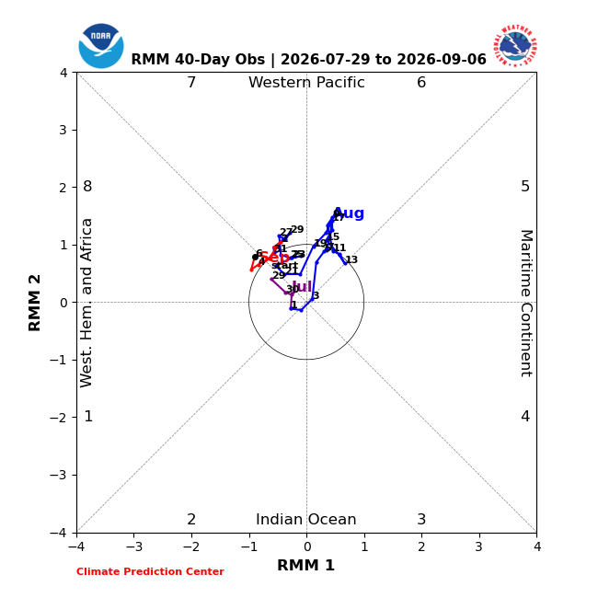
Figure 1. Current MJO position as of August 2nd Dekad, 2026
From figure 2, the MJO trajectory over the 40-day observation window remained largely within the unit circle, indicating weak and indeterminate amplitude for much of the period. The signal transited mainly between Phase 1 (Western Hemisphere and Africa) and Phase 2 (Indian Ocean), with only a brief, weak excursion toward Phase 5 (Maritime Continent) in early August. A weak, indeterminate MJO signal implies limited direct influence on convection over Ghana during the dekad, meaning rainfall was more likely driven by local and synoptic-scale systems (such as the ITF and mesoscale convective activity) than by the MJO.

1.0 RAINFALL AND TEMPERATURE DISTRIBUTION

1.1 Rainfall
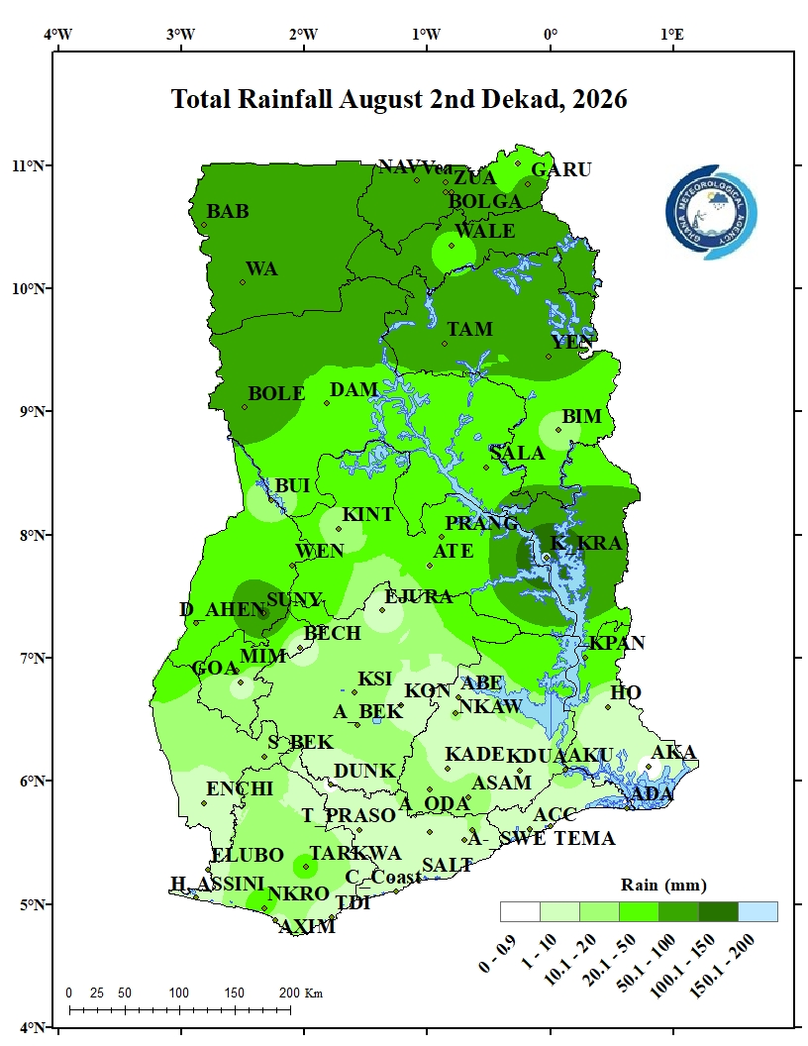 | 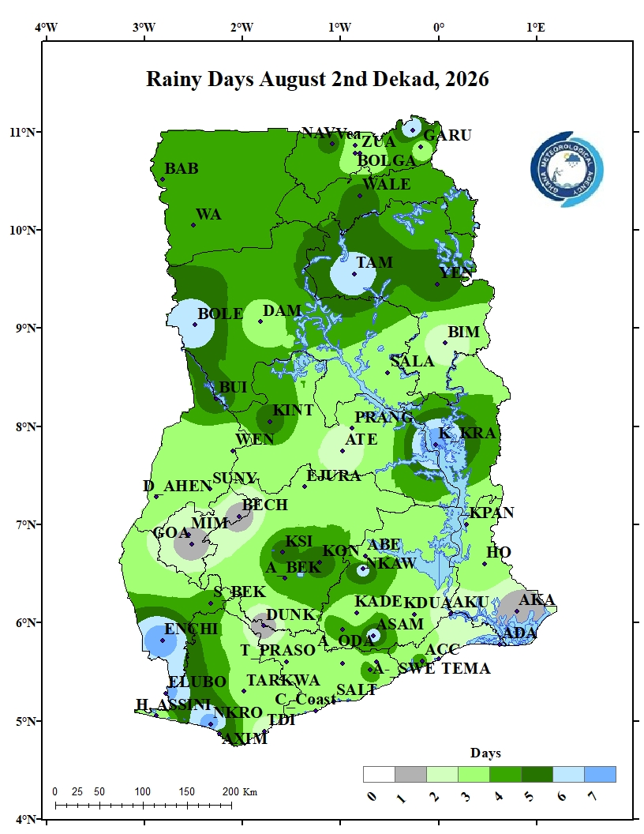
Figure 2a: Total Rainfall August 2nd Dekad, 2026 | Figure 2b: Rainy Days August 2nd Dekad, 2026
Figure 3a illustrates the rainfall distribution across Ghana during the second ten day period of August. Rainfall was more widespread than in the previous dekad, with several localised high-rainfall pockets (100.1–200 mm) recorded in the far north around Bawku and Garu, in the Transition sector around Kete Krachi, and in the west around Dormaa Ahenkro and Sunyani. The coastal sector generally recorded lower rainfall totals, though not as low as the previous dekad.
Figure 3b also illustrates the frequency of rainy days during the specified period. The highest number of rainy days (7 days) was recorded around Kete Krachi, Bole, Nkronza and Enchi. The coastal sector, including Accra and Tema, recorded fewer rainy days (2-3 days), an improvement on the near rain-free conditions of the previous dekad.

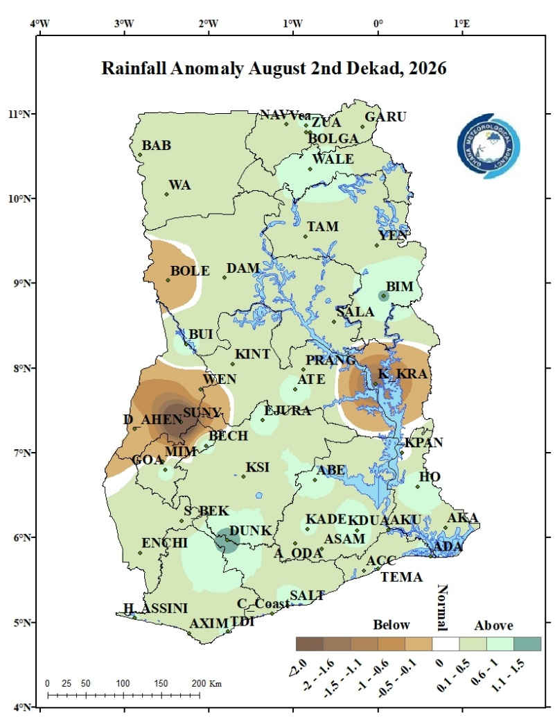
Figure 3: Rainfall Anomaly for August 2nd Dekad, 2026
Figure 4 highlights areas with deviations from normal rainfall. Surplus (above-normal) rainfall was recorded over the entire coastal belt and most parts of the forest, transition and the northern belt. Areas around Sunyani, Dormaa Ahenkro, Wenchi, Mim, Bole and Kete Krachi recorded below normal rainfall.

1.2 Temperature
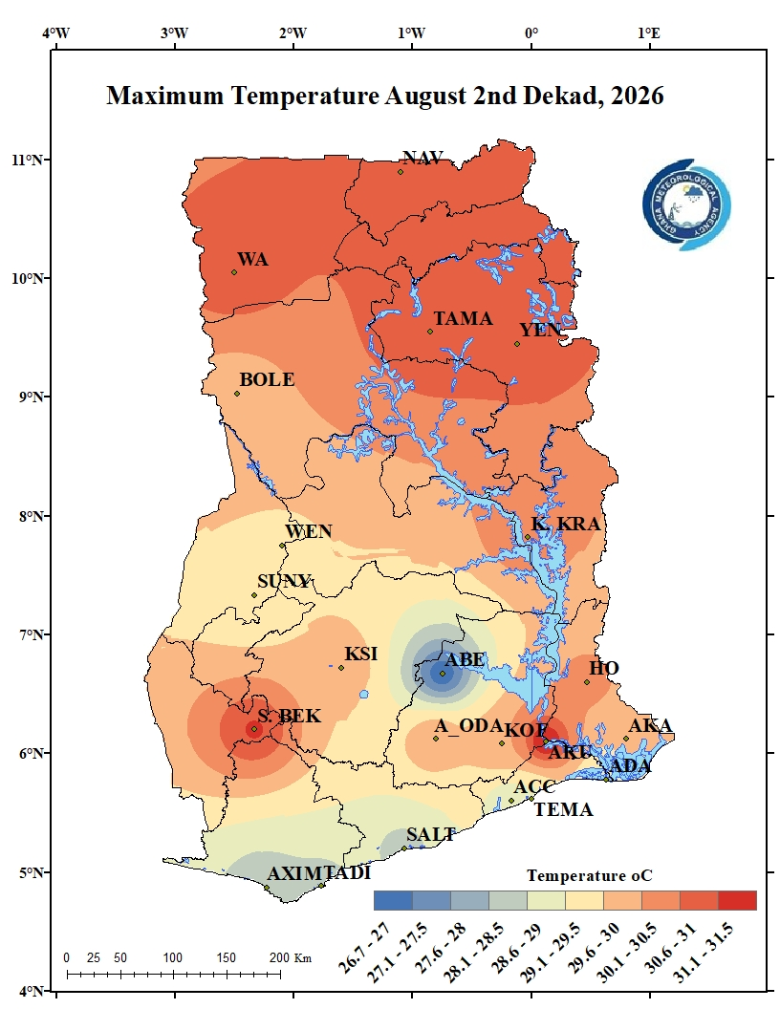 | 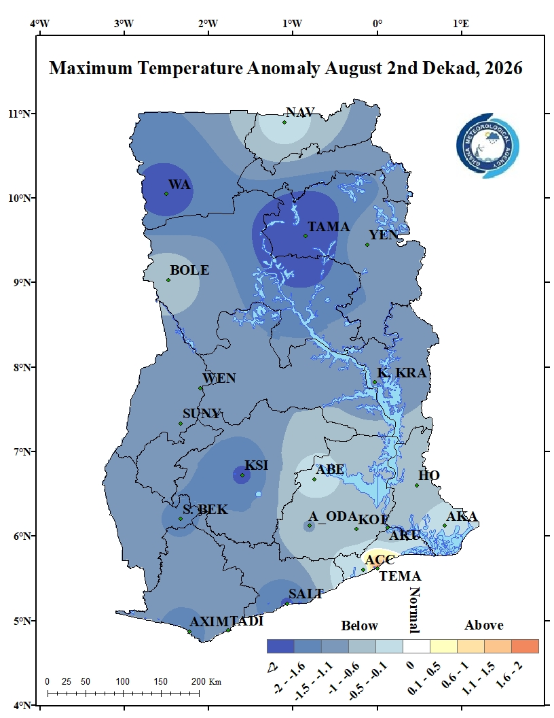
Figure 4a. Maximum Temperature August 2nd Dekad, 2026. | Figure 4b. Maximum Temperature Anomaly August 2nd Dekad, 2026.
Figure 5a displays the distribution of average daytime temperatures across the country. Wa, Tamale and Yendi the Northern belt and Sefwi Bekwai and Akuse in the forest belt recorded the highest temperatures, ranging between 31.1–31.5°C. The coolest maximum temperature of 26.7°C was recorded at Abetifi. Stations within the coastal belt such as Axim, Takoradi, Saltpond, Accra, Tema and Ada recorded daytime temperatures between 28.1 - 29°C. Temperaturues over the rest os the country ranged between 29.1 - 31°C.
Maximum Temperature Anomaly as represented in figure 5b above were below normal across almost the entire country. The largest deficits occurred over Wa and Tamale in the north and around Kumasi in the forest zone. Accra and Tema recorded slightly above-normal maximum temperatures during the period.

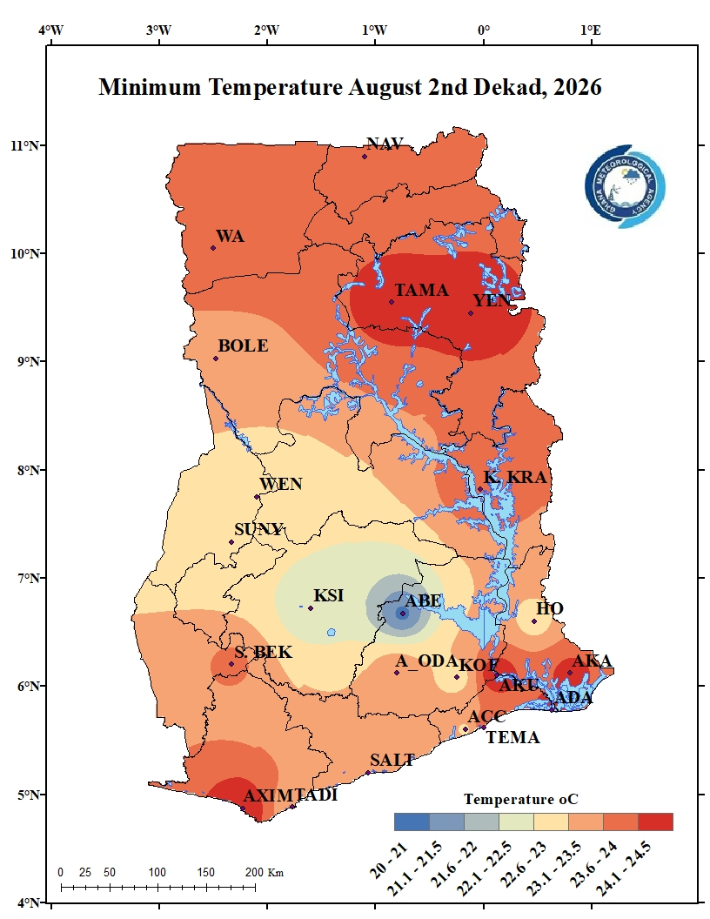 | 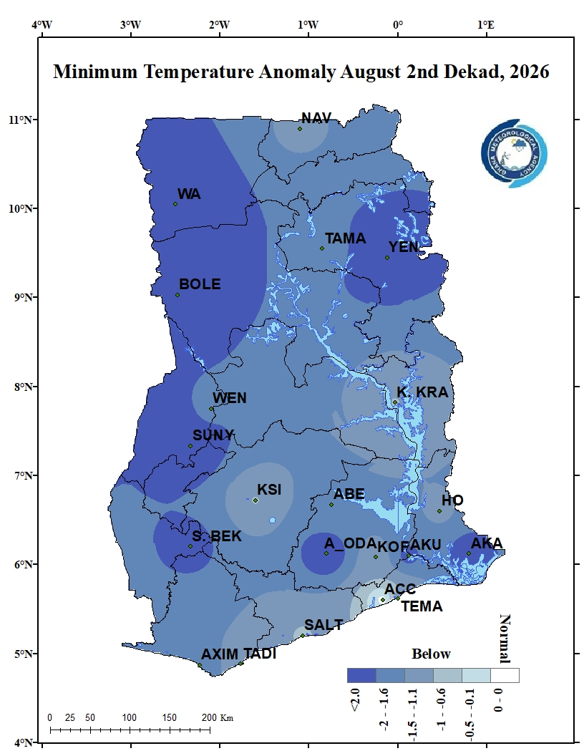
Figure 5a. Minimum Temperature August 2nd Dekad, 2026 | Figure 5b. Minimum Temperature Anomaly August 2nd Dekad, 2026
The highest average nighttime temperatures of 24.5°C were recorded over Axim in the coastal belt. Tamale and Yendi in the northern belt also recorded high night time temperatures of 24.3°C. The lowest minimum temperature of 20.9°C was recorded over Abetif in the forest belt. Night time temperatures over the rest of the country ranged between 22.1-24°C.
Minimum temperatures were below normal across the entire country during this dekad. The highest deficits (below -2.0°C) occurred over Wa, Bole, Sefwi Bekwai and Akim Oda.
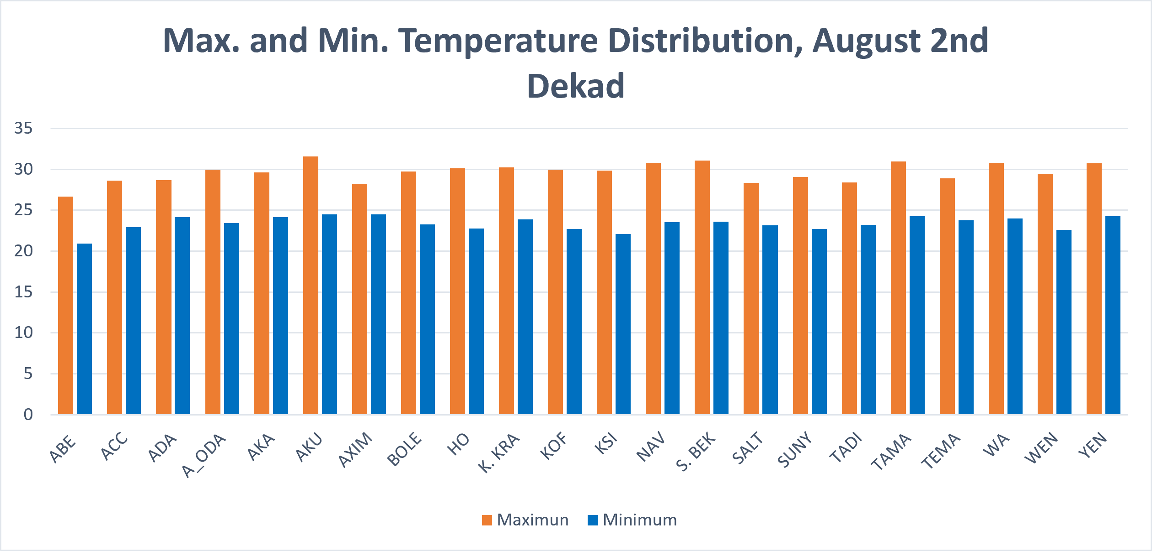
Figure 6. Max. and Min. Temperature Distribution for August 2nd Dekad, 2026

2.0 RAINFALL AND TEMPERATURE OUTLOOK 21ST AUGUST – 3RD SEPTEMBER 2026
For the coming week, rainfall is projected to remain above-normal across the eastern half of the country and parts of the far north, while below-normal rains are expected across the west-central and south-western sectors, consistent with the anomaly pattern observed during this dekad. Temperatures are expected to remain below-normal across most of the country, particularly in the north and around the forest zone.
For week 2, below-normal rainfall is expected to persist over the west-central belt, while near- to above-normal rainfall is expected in the north and along the eastern corridor. Temperatures are projected to remain below-normal nationwide, with the coolest anomalies confined to the northern and forested sectors; conditions closer to normal are expected along the immediate coast.
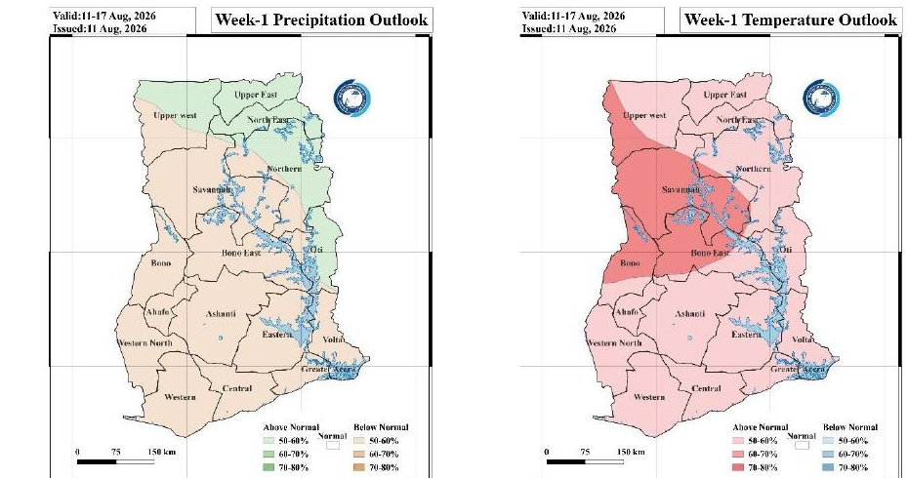
Week 1 Precipitation and Temperature Outlook
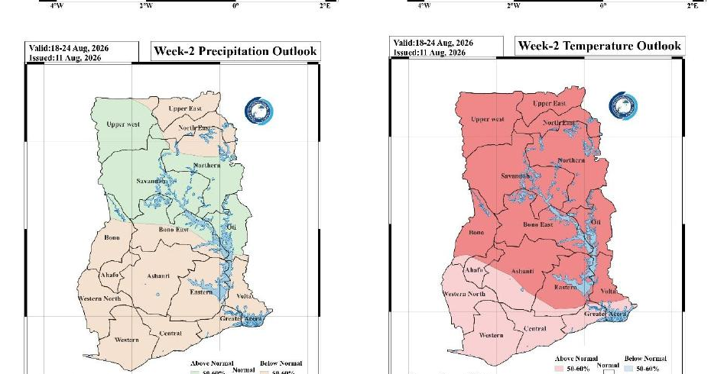
Week 2 Precipitation and Temperature Outlook

3.0 ADVISORIES

1. Health Sector
- Below-normal temperatures, especially in the mornings and at night, may increase the risk of common cold and other cold-related discomfort, particularly in the Northern belt and forest zone.
- Increased rainfall and standing water raise the risk of malaria and other mosquito-borne diseases; vulnerable groups (children, the elderly, and pregnant women) should take extra precautions such as sleeping under treated nets.

2. Water Resources Management Sector
- Monitor water levels in dams, rivers and low-lying areas in the high-rainfall zones (far north, Kete Krachi, Dormaa Ahenkro/Sunyani) for potential localised flooding or runoff.
- Continue water conservation practices in the west-central belt (Sunyani, Dormaa Ahenkro, Wenchi, Bui, Bole) where rainfall remained below normal.

3. General Public
- Below-Normal Temperatures (Nationwide). The public should dress warmly, especially during early mornings and at night, particularly in the north and forest zone.
- Carry rain gear and exercise caution on roads in high-rainfall areas, where surfaces may be slippery or prone to localised flooding.
- Farmers in the west-central belt should note the rainfall deficit and plan irrigation or water use accordingly.
- Stay updated on weather forecasts from the Ghana Meteorological Agency.

4.0 APPENDIX

4.1 Table of Stations
Station | Abbreviation | Station | Abbreviation
Abetifi | ABE | Kete Krachi | K_KRA
Accra | ACC | Kade | KADE
Ada | ADA | Koforidua | KDUA
Akatsi | AKA | Kintampo | KINT
Akim Oda | A_ODA | Ho | HO
Akuse | AKU | Kpando | KPAN
Asamankese | ASAM | Kumasi | KSI
Atebubu | ATE | Mim | MIM
Axim | AXIM | Navrongo | NAV
Babile | BAB | Prang | PRANG
Bechem | BECH | Sefwi Bekwai | S_BEK
Bimbila | BIM | Salaga | SALA
Bole | BOLE | Saltpond | SALT
Bolga | BOLGA | Sunyani | SUNY
Bongo | BON | Pong Tamale | P_TAM
Bui | BUI | Tamale | TAM
Cape Coast | C_COAST | Takoradi | TDI
Damongo | DAM | Vea | VEA
Dompase | DOM | Asankragua | ASAN
Dormaa Ahenkro | D_AHEN | Tema | TEMA
Dunkwa Offin | DUNK | Wa | WA
Ejura | EJURA | Walewale | WALE
Elubo | ELUBO | Obuasi | OBU
Enchi | ENCH | Wenchi | WEN
Garu | GARU | Yendi | YEN
Goa | GOA | Zuarungu | ZUA
Half Assini | H_ASS | Assin Fosu | A_FOSU
Hunney Valley | H_VAL | Winneba | WIN
Konongo | KON | Bosomtwe | BOSOM
Mankranso | MANK | Techiman | TECH
Oti | OTI | Kajaji | KAJ

For further inquiries, clarification, information or assistance
Contact:
The Director General
Tel. +233 (0)30 701 0019 or clients@meteo.gov.gh / info@meteo.gov.gh

