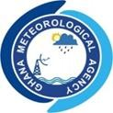
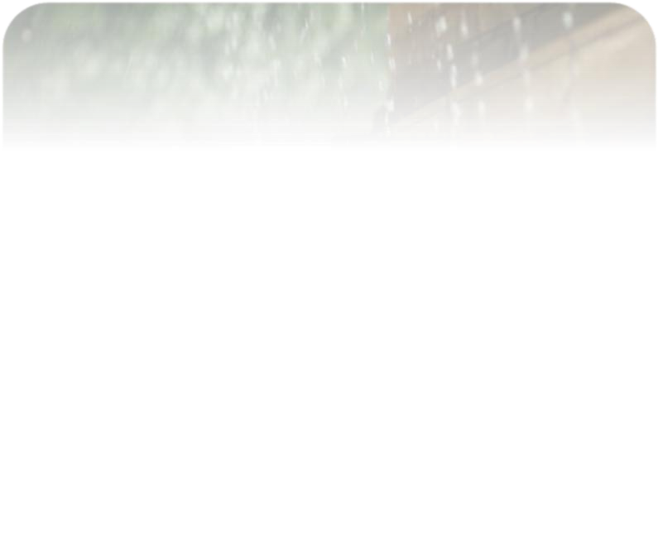
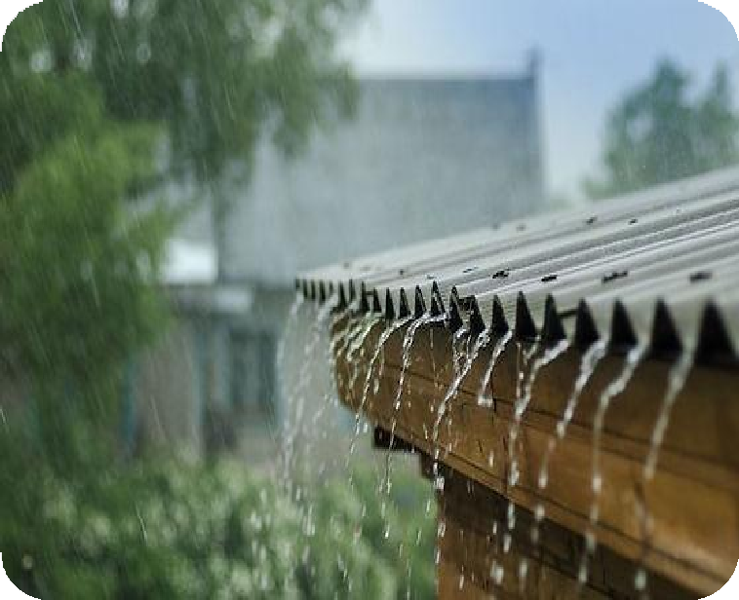


SEPTEMBER 2026
CLIMATE BULLETIN

DEKAD 1, SEPTEMBER (01-10)
GMET/CLIMATE/110826 FORM338
9/01/2026

Contents
SUMMARY 4

OBSERVED CLIMATE DRIVERS 4
Intertropical Front 4
Madden-Julian Oscillation (MJO) 6

1.0 RAINFALL AND TEMPERATURE DISTRIBUTION 8
1.1 Rainfall 8
1.2 Temperature 10

2.0 RAINFALL AND TEMPERATURE OUTLOOK 1ST - 14TH SEPTEMBER 2026 12

3.0 ADVISORIES 14
1. Health Sector 14
2. Water Resources Management Sector 14
3. General Public 14

4.0 APPENDIX 15
4.1 Table of Stations 15

LIST OF FIGURES

Figure 1: Current ITF Position for September 1st Dekad, 2026 5

Figure 2: Current MJO position as of September 1st Dekad, 2026 6

Figure 3a: Total Rainfall September 1st Dekad, 2026 8

Figure 3b: Rainy Days September 1st Dekad,2026 8

Figure 4: Rainfall Anomaly for September 1st Dekad, 2026 9

Figure 5a: Maximum Temperature September 1st Dekad, 2026 10

Figure 5b: Maximum Temperature Anomaly September 1st Dekad, 2026. 10

Figure 6a: Minimum Temperature September 1st Dekad, 2026 11

Figure 6b: Minimum Temperature Anomaly September 1st Dekad, 2026 11

Figure 7: Max. and Min. Temperature Distribution for September 1st Dekad, 2026 12

SUMMARY
- Rainfall:
  - Most areas received moderate to high rainfall, with few places recording values exceeding 100 mm.
  - The highest rainfall of 180 mm was recorded at Kintampo in the transition zone.
  - The highest rainy day (up to 9 days) was recorded at Bui.
- Rainfall Anomalies:
  - Surplus rainfall was recorded over most parts of the middle portions of the country.
  - Deficit rainfall was concentrated in the northern and southern portions of the country.
- Temperatures:
        - Maximum:
  - Highest maximum temperature of 33.23°C was recorded over Akuse in the forest zone.
  - Lowest maximum temperature of 27.76°C, was recorded at Abetifi in the forest zone.
  - Maximum temperatures were above normal across the country except at Ada, where a marginally below normal temperature was recorded.
Minimum:
  - The lowest minimum temperature of 21.06°C was recorded at Abetifi in the forest belt.
  - The highest minimum temperature of 25.0°C was recorded at Akuse.
  - Minimum temperatures were above normal throughout the country, aside from Accra, where a slightly below normal temperature was recorded.

OBSERVED CLIMATE DRIVERS

Intertropical Front
Also known as the Intertropical Convergence Zone (ITCZ) is a critical meteorological feature that significantly influences weather patterns in West Africa, including Ghana. The ITF is a boundary zone where the warm, moist air from the Atlantic Ocean (southwesterly monsoon winds) meets the hot, dry air from the Sahara Desert (northeasterly Harmattan winds). This convergence leads to the formation of clouds and precipitation, making it a key driver of the rainy season in West Africa. The northward movement of the ITF during March-July brings the rainy season to Ghana.

Between September 1 and 10, the Inter-Tropical Front (ITF) is observed to have moved southwards as compared to its position during the previous dekad. This may have influenced the amount of rainfall received at the middle portions of the country during the dekad. The ITF was located in the northern portions of Mali during the 3rd dekad of August, consistent with the slow, near-stationary behavior typical of the ITF at this stage of the monsoon season. Table 1 below shows the evolving ITF's position over Ghana, located between 5W and 5E.
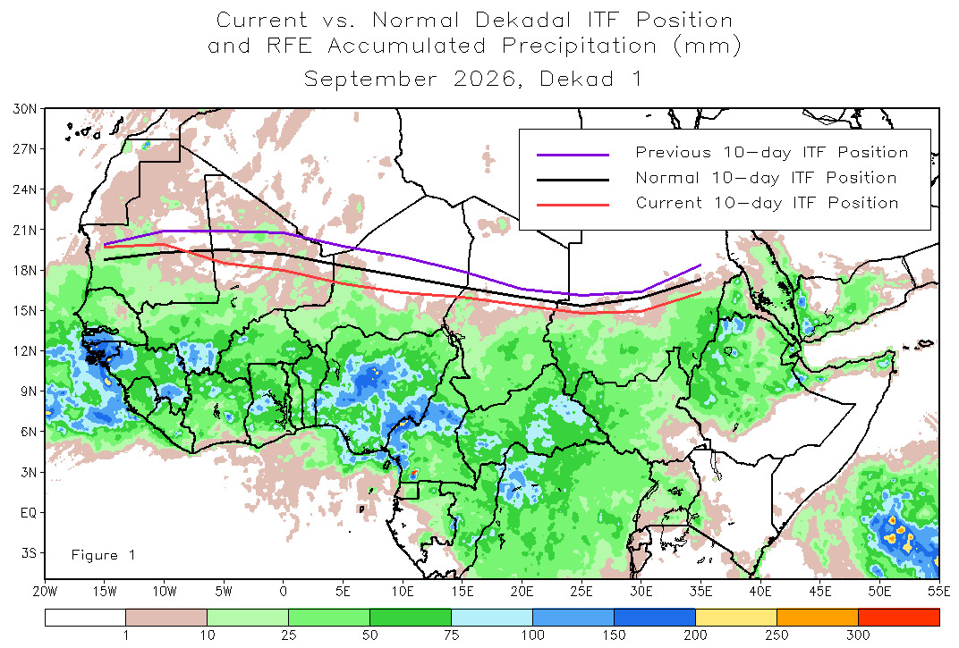
Figure 1: Current ITF Position for September 1st Dekad, 2026

DEKAD | 5W | 0 | 5E
January 1 | 10.7 | 9.0 | 6.6
January 2 | 6.4 | 6.6 | 9.4
January 3 | 6.5 | 6.5 | 7.6
February 1 | 9.3 | 10.2 | 9.6
February 2 | 10.7 | 10.9 | 10.4
February 3 | 8.6 | 8.5 | 7.8
March 1 | 10.6 | 11.2 | 10.0
March 2 | 10.7 | 10.1 | 9.9
March 3 | 12.6 | 14.1 | 11.8
April 1 | 12.7 | 12.2 | 11.5
April 2 | 12.7 | 12.2 | 12.5
April 3 | 15.5 | 14.6 | 13.5
May 1 | 16.7 | 15.5 | 14.8
May 2 | 16.2 | 15.7 | 14.6
May 3 | 16.0 | 15.8 | 15.7
June 1 | 15.7 | 16.2 | 17.1
June 2 | 16.8 | 17.4 | 17.7
June 3 | 18.2 | 19.0 | 18.9
July 1 | 16.6 | 17.9 | 17.7
July 2 | 20.1 | 19.6 | 18.5
July 3 | 20.3 | 19.1 | 18.5
August 1 | 19.2 | 19.1 | 18.7
August 2 | 20.4 | 20.7 | 19.8
August 3 | 20.9 | 20.8 | 19.8
September 1 | 18.5 | 18.0 | 17.0
Table 1. Dekadal evolution of the ITF position over Ghana 2026.

Madden-Julian Oscillation (MJO)
MJO is a tropical disturbance that moves eastward around the globe, influencing weather patterns, including rainfall and temperature, in various regions. The MJO has phases (1-8), with each phase corresponding to its location over the tropics. Its position and strength can have significant implications for weather in Ghana, particularly during the West African monsoon season.
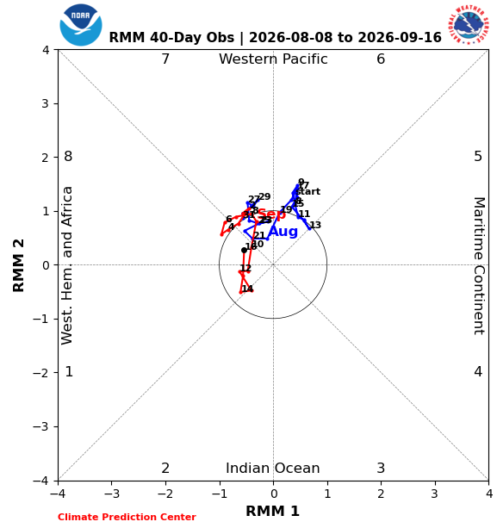
Figure 2: Current MJO position as of September 1st Dekad, 2026
From figure 2, the MJO trajectory over the 40-day observation window remained largely within the unit circle, indicating weak and indeterminate amplitude for much of the period. The signal transited mainly between Phase 1 (Western Hemisphere and Africa) and Phase 7 (Western Pacific), with only a brief movement out of the circle during the dekad. A weak, indeterminate MJO signal implies limited direct influence on convection over Ghana during the dekad, meaning rainfall was more likely driven by local and synoptic-scale systems (such as the ITF and mesoscale convective activity) than by the MJO.

1.0 RAINFALL AND TEMPERATURE DISTRIBUTION

1.1 Rainfall
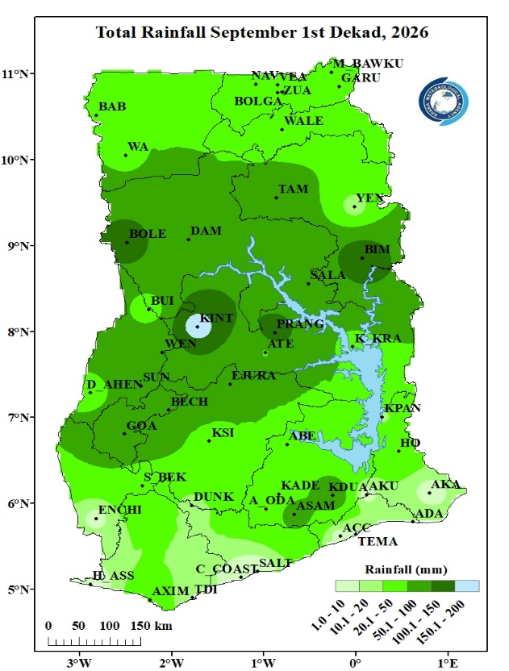  Figure 3a: Total Rainfall September 1st Dekad, 2026 | 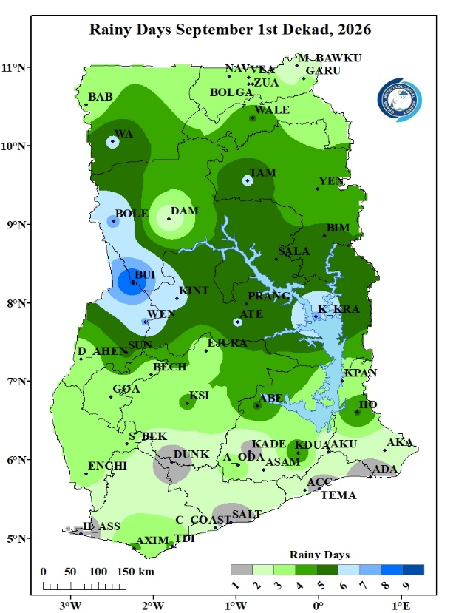  Figure 3b: Rainy Days September 1st Dekad,2026
Figure 3a illustrates the rainfall distribution across the country during the first dekad of September. Rainfall was more concentrated in the middle portions of the country, specifically at portions of the forest, transition and southern parts of the north. Rainfall values between 50 and 200mm were recorded at these areas. The highest rainfall amount was recorded at Kintampo (180mm). Lower rainfall amounts (less than 10mm) were recorded at the coast and parts of the forest zone with the lowest amount being recorded at Saltpond in the eastern coast.
Figure 3b illustrates the frequency of rainy days during the period under review. The highest number of rainy days (9 days) was recorded at Bui in the transition zone. The next highest rainy day of 7 was recorded at Bole, Kete Krachi and Wenchi. The least number of rainy days (1) was recorded at Half- Assini, Tema, Saltpond, Kade, Dunkwa and Ada.

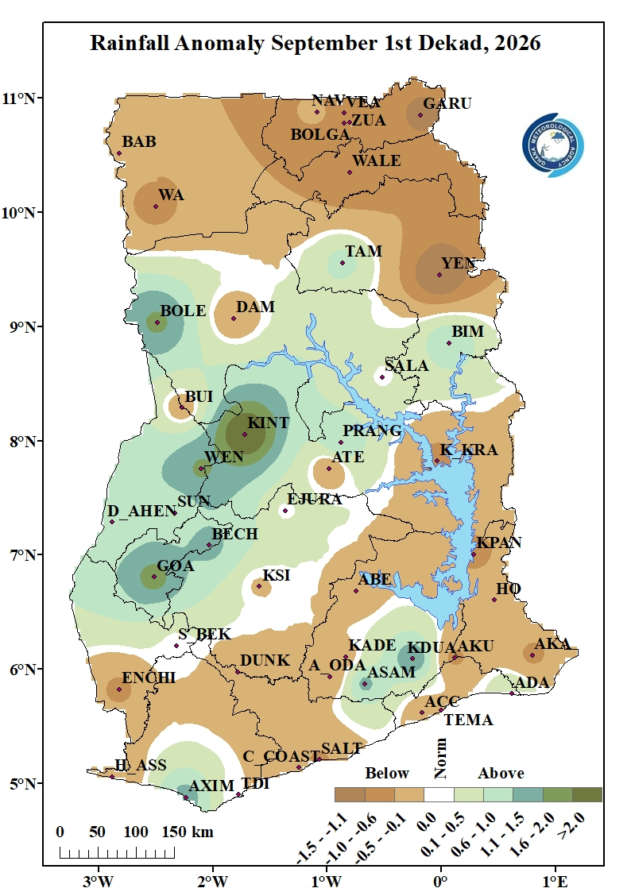
Figure 4: Rainfall Anomaly for September 1st Dekad, 2026
Figure 4 highlights areas with deviations from normal rainfall. Surplus (above-normal) rainfall was recorded over parts of the middle portions of the country and few places at the coastal zone. These places include but are not limited to Ada, Axim, Asamankese, Goaso, Kintampo, Dormaa Ahenkro, Bole, Tamale and Bimbila. Most parts of the north (Babile, Wa, Walewale, Yendi etc.) and some areas in the south (Enchi, Cape Coast, Accra, Tema, Ho, Kpando, Akuse etc.) experienced below normal rainfall. Normal rainfall was recorded at Sefwi Bekwai, Ejura, and Salaga.

1.2 Temperature
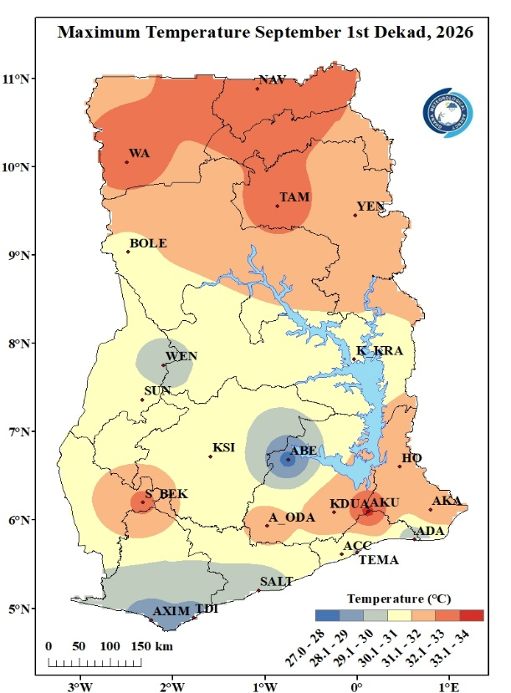  Figure 5a: Maximum Temperature September 1st Dekad, 2026 | 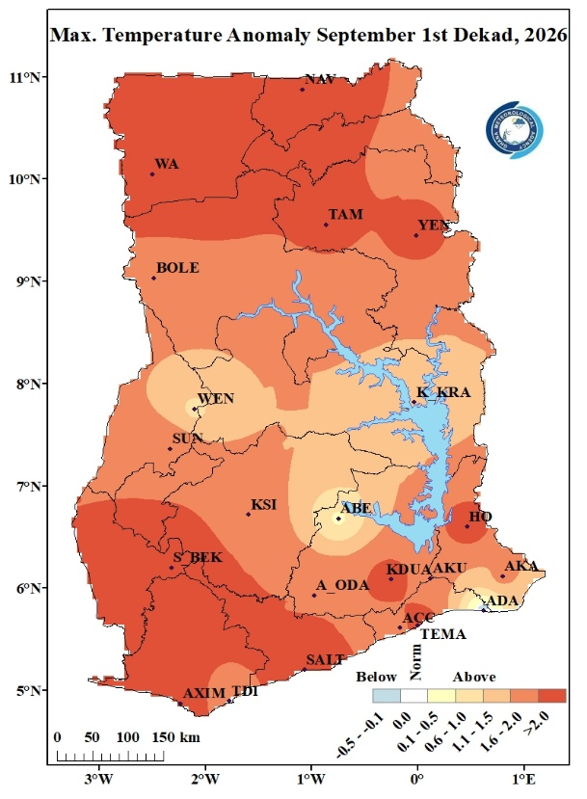  Figure 5b: Maximum Temperature Anomaly September 1st Dekad, 2026.
Figure 5a shows the distribution of average daytime (maximum) temperatures across the country. Wa, Tamale and Navrongo at the northern portions and Sefwi Bekwai and Akuse in the forest zone recorded the highest temperatures, ranging between 32.1°C-34.0°C with Akuse recorded the highest temperature of 33.23°C during the dekad. Abetifi recorded the coolest maximum temperature of 27.76°C. Stations such as Wenchi, Axim, Takoradi, Saltpond and Ada recorded temperatures between 27.0°C and 30.0°C whereas the rest of the country recorded temperatures ranging from 30.1°C – 31.0°C.
Maximum Temperature Anomaly as illustrated in figure 5b were above normal across almost the entire country except for Ada where a marginally below normal temperature was recorded. The largest anomalies occurred over Wa, Navrongo, Yendi and Tamale in the north, Sefwi Bekwai, Axim, Koforidua, and Ho in the forest zone. Tema and Saltpond in the eastern coast also recorded high anomaly during the period.

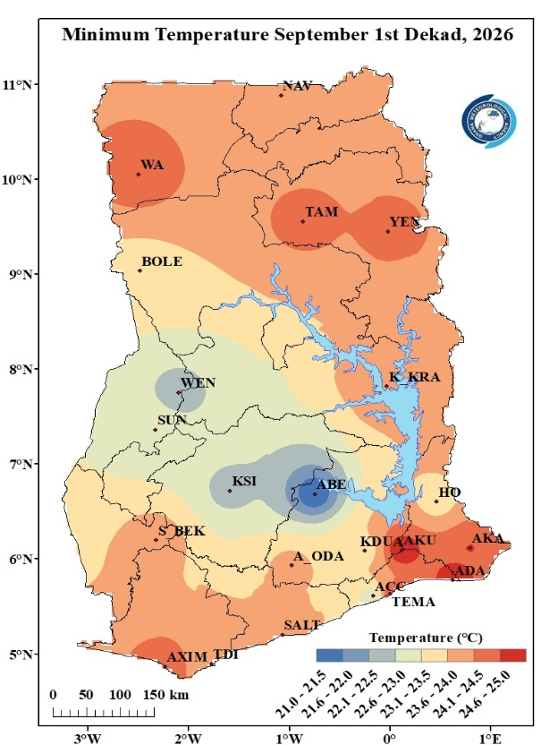  Figure 6a: Minimum Temperature September 1st Dekad, 2026 | 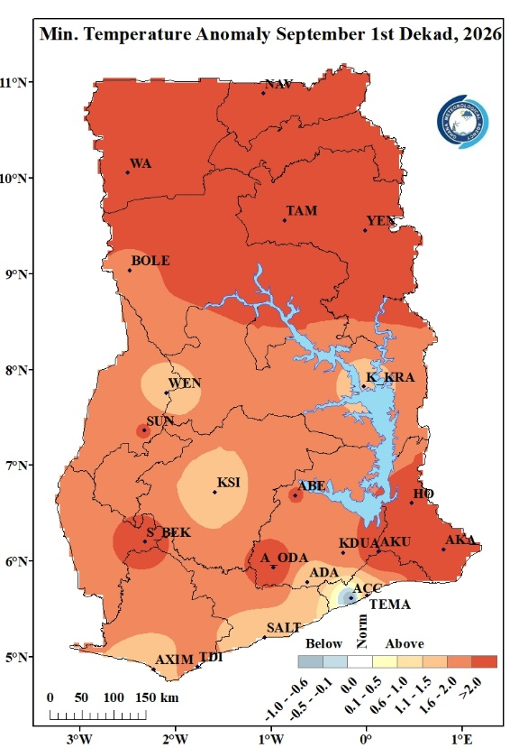  Figure 6b: Minimum Temperature Anomaly September 1st Dekad, 2026
In figure 6a above, the highest nighttime temperatures recorded during the dekad ranged from 24.6°C-25.0°C at Akuse, Ada and Akatsi with Akuse recording the highest value of 25.0°C. The lowest nighttime temperature was recorded at Abetifi in the forest zone with a value of 21.06°C. Night time temperatures over the rest of the country ranged between 21.6°C – 24.5°C.
Minimum temperatures were above normal across almost the entire country during this dekad. Accra, however, recorded below normal temperature The highest anomaly (above 2.0°C) occurred over most places in the north, Ho, Akatsi, Akuse, Sefwi Bekwai, Akim Oda, Sunyani, and Abetifi.

Figure 7: Max. and Min. Temperature Distribution for September 1st Dekad, 2026

2.0 RAINFALL AND TEMPERATURE OUTLOOK 1ST - 14TH SEPTEMBER 2026
For week 1, rainfall is expected to be below normal across the entire country. The northern zone and eastern sections of the transition zone are having a greater probability or chance of below-normal rainfall. Temperatures are also expected to be above normal across the country, with the northern parts having a higher likelihood of experiencing above-normal temperatures.

For Week 2, below-normal rainfall is expected to continue across most parts of the country, while the northern belt is likely to receive above-normal rainfall. Temperatures are projected to remain above normal nationwide, with a higher likelihood of above-normal temperatures across the northern parts of the country and portions of the transition zone.

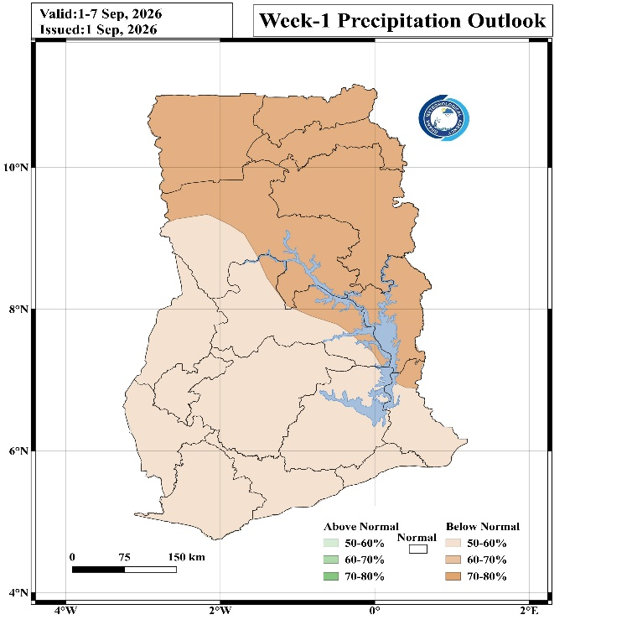
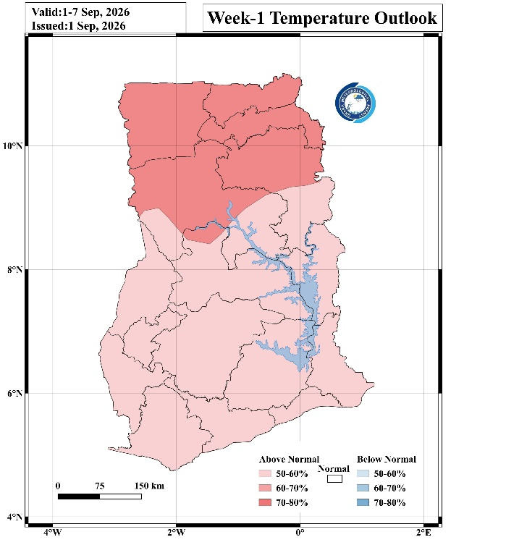
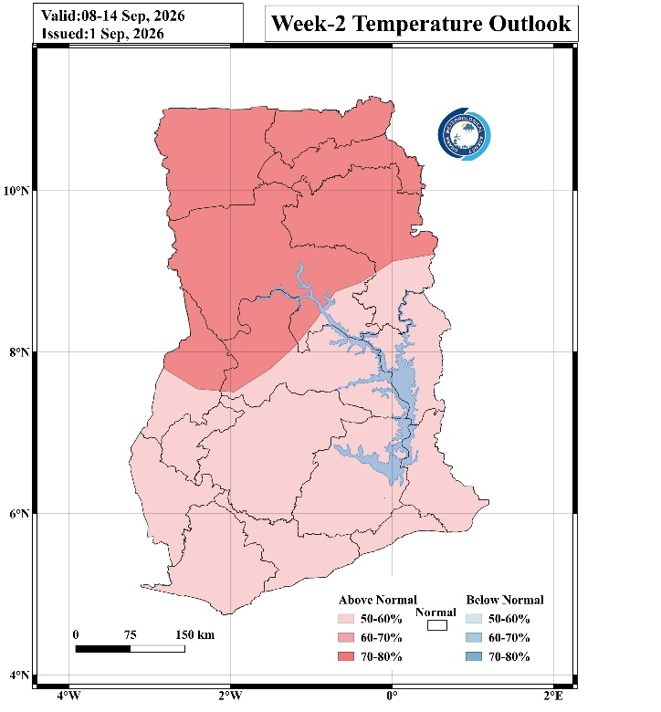
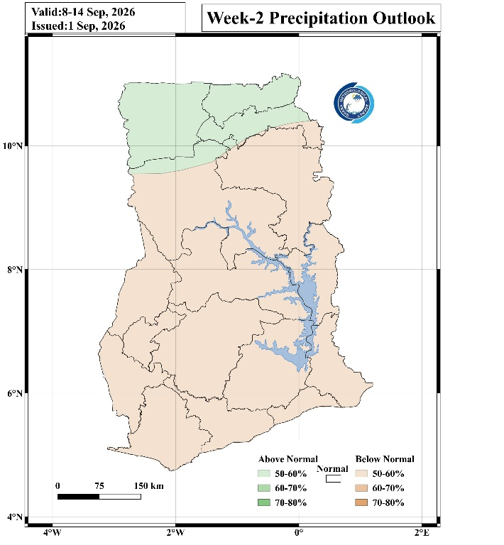
Week 1 Precipitation and Temperature Outlook

Week 2 Precipitation and Temperature Outlook

3.0 ADVISORIES

1. Health Sector
- Above-normal temperatures may increase the risk of heat stress and other heat-related illnesses, particularly in the northern and transition zones.
- Health service providers should stay alert and monitor cases of cholera and other water-borne diseases in areas where below normal rainfall is expected.
- Increased rainfall and standing water may raise the risk of malaria and other mosquito-borne diseases; vulnerable groups (children, the elderly, and pregnant women) should take extra precautions such as sleeping under treated nets.

2. Water Resources Management Sector
- Monitor water levels in dams, rivers and low-lying areas in the high-rainfall zones (Wa, Babile, Bolgatanga, and their surrounding communities) for potential localised flooding or runoff.
- Water conservation practices should be encouraged across the country, especially at places where rainfall is expected to remain below normal.

3. General Public
- Above-normal temperatures (Nationwide). The public should wear light clothing and try as much as possible to stay under shade during peak sunshine hours, particularly in the north and transition zones.
- Carry appropriate rain gear and exercise caution when travelling on roads in areas experiencing heavy rainfall, where surfaces may be slippery or prone to localised flooding.
- Farmers should note the rainfall deficit and plan irrigation or water use accordingly.
- Stay updated on weather forecasts from the Ghana Meteorological Agency.

4.0 APPENDIX

4.1 Table of Stations
Station | Abbreviation | Station | Abbreviation
Abetifi | ABE | Kete Krachi | K_KRA
Accra | ACC | Kade | KADE
Ada | ADA | Koforidua | KDUA
Akatsi | AKA | Kintampo | KINT
Akim Oda | A_ODA | Ho | HO
Akuse | AKU | Kpando | KPAN
Asamankese | ASAM | Kumasi | KSI
Atebubu | ATE | Mim | MIM
Axim | AXIM | Navrongo | NAV
Babile | BAB | Prang | PRANG
Bechem | BECH | Sefwi Bekwai | S_BEK
Bimbila | BIM | Salaga | SALA
Bole | BOLE | Saltpond | SALT
Bolga | BOLGA | Sunyani | SUNY
Bongo | BON | Pong Tamale | P_TAM
Bui | BUI | Tamale | TAM
Cape Coast | C_COAST | Takoradi | TDI
Damongo | DAM | Vea | VEA
Dompase | DOM | Asankragua | ASAN
Dormaa Ahenkro | D_AHEN | Tema | TEMA
Dunkwa Offin | DUNK | Wa | WA
Ejura | EJURA | Walewale | WALE
Elubo | ELUBO | Obuasi | OBU
Enchi | ENCH | Wenchi | WEN
Garu | GARU | Yendi | YEN
Goa | GOA | Zuarungu | ZUA
Half Assini | H_ASS | Assin Fosu | A_FOSU
Hunney Valley | H_VAL | Winneba | WIN
Konongo | KON | Bosomtwe | BOSOM
Mankranso | MANK | Techiman | TECH
Oti | OTI | Kajaji | KAJ

For further inquiries, clarification, information or assistance
Contact:
The Director General
Tel. +233 (0)30 701 0019 or clients@meteo.gov.gh / info@meteo.gov.gh

