**GHANA METEOROLOGICAL AGENCY**



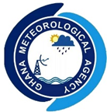

**HEADQUARTERS, LEGON ACCRA**

**(DIGITAL ADDRESS: GA-485-3581)**

**37 TRINITY ROAD, EAST LEGON**

**P. O. BOX LG 87, LEGON, ACCRA-GHANA**

**SEPTEMBER 2025 RAINFALL OUTLOOK OVER GHANA**

***GMET/HYDRO/0925 Date Issued: 29thAugust 2025***

***FORM 902***

**SUMMARY**

The monthly rainfall outlook for September 2025 indicates that most parts of the country are expected to experience normal rainfall, with above-normal rainfall anticipated over portions of the northern zones, while below-normal rainfall is likely along the west coast. **Figure 1(a)** shows the rainfall climatology (1991-2020) for June. **Figure 1(b)** displays the spatial distribution of the expected total rainfall for September 2025. **Figure 1(c)** shows the September 2025 rainfall probabilities (or percent chances) for each of the three categories: above normal, normal, and below normal.

**SEPTEMBER 2025 RAINFALL FORECAST (PROBABLISTIC)**

**SEPTEMBER 2025 RAINFALL FORECAST (DETERMINISTIC)**

**SEPTEMBER RAINFALL CLIMATOLOGY (1991-2020)**

**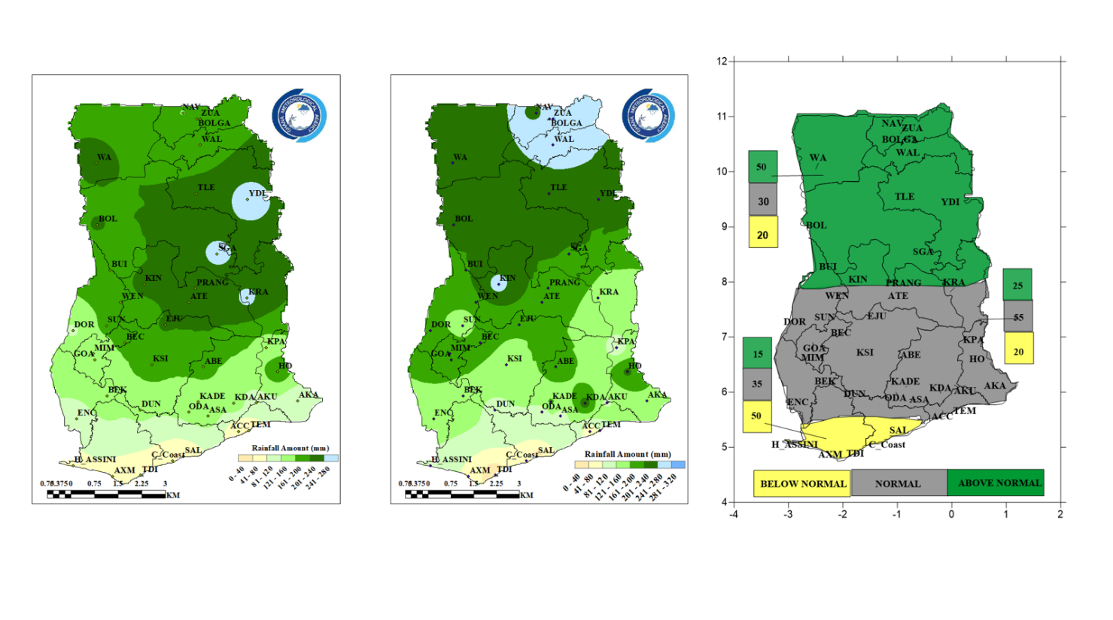Figure 1:** **(a)** Monthly rainfall climatology for September (1991-2020). **(b)** Deterministic rainfall forecast for September 2025. **(c)** Probabilistic rainfall forecast for September 2

**(a)**

**(b)**

**(c)**

**DESCRIPTION OF THE FORECAST**

**The Savanna zone**

The Savanna zone predominantly shows higher chances of normal to above normal rainfall.

**The Transition zone**

Areas such as Bui, Kintampo, and Kete-Krachi in the northern part of the Transition Zone are expected to experience normal to above-normal rainfall, while Dormaa, Sunyani, Atebubu, and Goaso in the southern section are expected to receive normal rainfall.

**The Forest zone**

Most parts of the Forest zone are expected to experience normal rainfall.

**The Coastal zone**

The Coastal zone mainly indicates higher chances of below normal to normal rainfall in areas such as Takoradi, Cape Coast, and Saltpond, while Accra and Tema with the remaining parts depicting normal rainfall.

**CATEGORY INFORMATION FOR RAINFALL FORECAST:**

* When the forecast indicates above normal, the total rainfall is above 125% of the climatology (1991-2020). One third of the months in that period were as wet as the forecast.
* When the forecast indicates near normal, the total rainfall is close to the climatology and falls in the range of 75% to 125% of the climatology.
* When the forecast indicates below normal, the total rainfall is below 75% of the climatology. One third of the months in that period were as dry as the forecast.

Please note that, in order to follow short-term weather variations, users of this outlook are advised to make use of the nowcast (six-hourly forecasts), daily forecasts and weekly forecasts routinely issued by the Ghana Meteorological Agency.

For further enquiries, clarification, information or assistance

Contact: The Director General – Ghana Meteorological Agency

Tel. +233 (0)30 701 0019 or clients@meteo.gov.gh/info@meteo.gov.gh