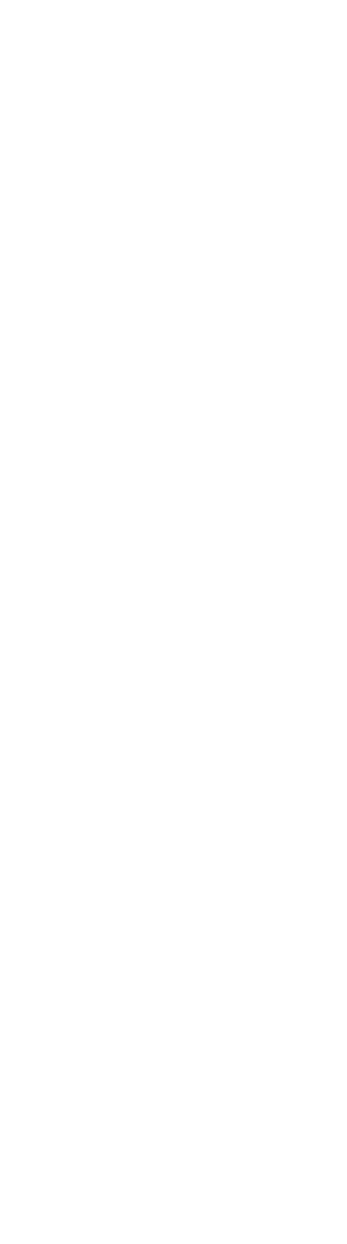
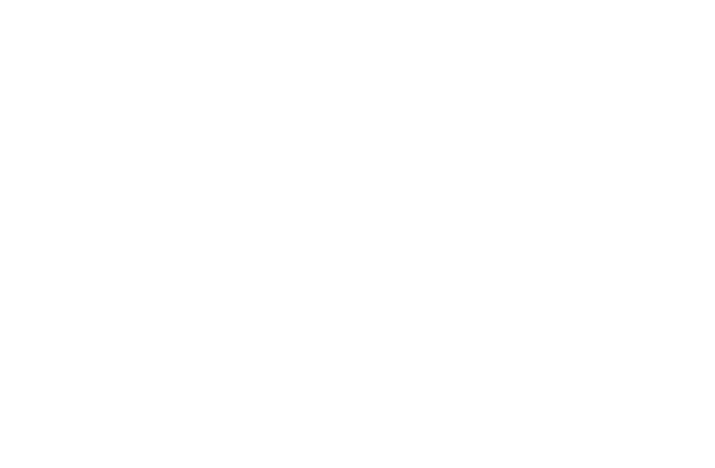
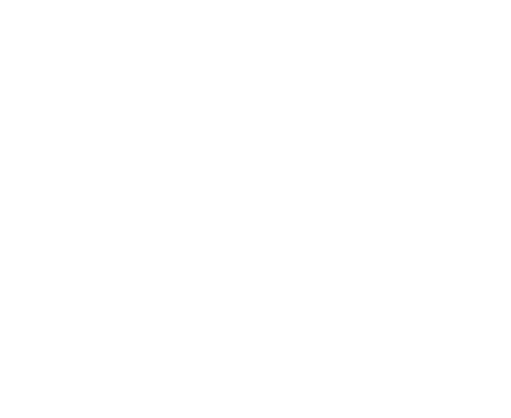
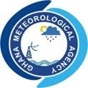

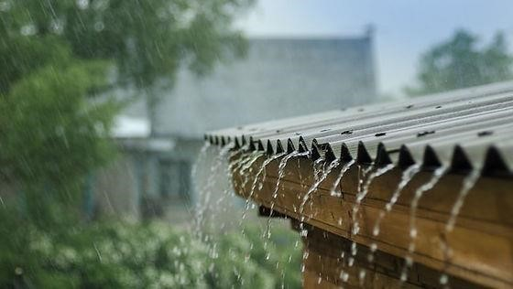



JULY
2025

DEKAD 3, July (21-30)

GMET/CLIMATE/0307
337
25
FORM

7
/
3/2025

CLIMATE BULLETIN

TABLE OF CONTENT

SUMMARY 4
1.0 OBSERVED CLIMATE DRIVERS 2
1.1 INTERTROPICAL FRONT 2
1.2 MADDEN-JULIAN OSCILLATION (MJO) 3
2.0 RAINFALL, TEMPERATURE AND RELATIVE DISTRIBUTION 5
2.1 RAINFALL 5
2.2 TEMPERATURE 7
2.3 RELATIVE HUMIDITY 10
3.0 RAINFALL AND TEMPERATURE OUTLOOK 1ST- 14TH OCTOBER 2025 11
4.0 ADVISORIES 12
5.0 APPENDIX 13
5.1 TABLE OF STATIONS 13



Website: www.meteo.gov.gh : @GhanaMet : Ghana Meteorological Agency (GMet)
Tel: 0307010019 Email: info@meteo.gov.gh ii

LIST OF FIGURES

Figure 1: Current ITF position for July 3rd Dekad, 2025 2
Table 1:Dekadal evolution of the ITF position over Ghana 2025 3
Figure 2: Current MJO position as of July 3rd Dekad, 2025 4
Figure 3a: Total Rainfall July 3rd Dekad, 2025 5
Figure 3 b: Rainy Days July 3rd Dekad, 2025 5
Figure 4: TAMSAT Total Rainfall July 3rd Dekad, 2025 6
Figure 5: Rainfall Anomaly for July 3rd Dekad, 2025 6
Figure 6a: Maximum Temperature July 3rd Dekad, 2025 7
Figure 6b: Maximum Temperature Anomaly July 3rd Dekad, 2025 7
Figure 7a: Minimum Temperature July 3rd Dekad, 2025 8
Figure 7b: Minimum Temperature Anomaly July 3rd Dekad, 2025 8
Figure 8: Max. and Min. Temperature Distribution for July 3rd Dekad, 2025 9
Figure 9a: Average Relative Humidity July 3rd Dekad, 2025 10
Figure 9b: Average Relative Humidity Anomaly July 3rd Dekad, 2025 10

iii

SUMMARY

- Rainfall:
  - Most areas in the country received rainfall below 50mm.
  - Wa received the highest rainfall of 185 mm.
  - Takoradi recorded the highest rainy days of 7 days.
- Rainfall Anomalies:
  - Deficit rainfall was recorded in most areas.
- Relative Humidity:
  - Maximum value of 86% was recorded over Saltpond
  - Minimum value of 68% was recorded over Tamale and Bole.
- Temperatures:
  - Maximum:
    - Above normal temperatures experienced in most parts of the country.
    - The maximum of the Maximum temperature of 31.6°C was recorded in Tamale.
    - The minimum of the maximum temperature of 25.9°C was recorded in Abetifi.
    - Relatively cooler temperatures along the coast and places in the forested areas.
  - Minimum:
    - Above normal temperatures recorded across the entire country
    - Warmer temperatures in the Northern and East Coastal sector
    - The maximum of the Minimum temperature was recorded in Tamale, reaching 24.4°C
    - The minimum of the Minimum temperature was recorded in Abetifi, reaching 19.8°C.

OBSERVED CLIMATE DRIVERS

1.1 INTERTROPICAL FRONT
Also known as the Intertropical Convergence Zone (ITCZ) is a critical meteorological feature that significantly influences weather patterns in West Africa, including Ghana. The ITF is a boundary zone where the warm, moist air from the Atlantic Ocean (south westerly monsoon winds) meets the hot, dry air from the Sahara Desert (northeasterly Harmattan winds). This convergence leads to the formation of clouds and precipitation, making it a key driver of the rainy season in West Africa. The northward movement of the ITF during March-July brings the rainy season to Ghana
DEKAD | 5W | 0 | 5E
January 1 | 7.2 | 7.6 | 7.8
January 2 | 7.3 | 7.8 | 7.5
January 3 | 7.9 | 8.2 | 8.5
February 1 | 6.6 | 8.1 | 8.3
February 2 | 9.6 | 9.0 | 8.8
February 3 | 8.2 | 9.2 | 8.9
March 1 | 11.0 | 10.5 | 10.1
March 2 | 10.0 | 9.8 | 9.6
March 3 | 11.6 | 11.6 | 11.2
April 1 | 11.1 | 11.3 | 11.1
April 2 | 12.8 | 11.7 | 11.1
April 3 | 13.5 | 13.1 | 12.1
May 1 | 13.9 | 13.7 | 12.7
May 2 | 14.1 | 13.9 | 13.8
May 3 | 14.5 | 14.7 | 14.2
June 1 | 14.4 | 15.9 | 16.5
June 2 | 15.8 | 15.9 | 18.1
June 3 | 16.5 | 16.4 | 17.5
July 1 | 18.1 | 18.4 | 17.6
July 2 | 20.4 | 20.5 | 18.5
July 3 | 20.5 | 20.9 | 19.8
Table 1:Dekadal evolution of the ITF position over Ghana 2025

1.2 MADDEN-JULIAN OSCILLATION (MJO)
MJO is a tropical disturbance that moves eastward around the globe, influencing weather patterns, including rainfall and temperature, in various regions. The MJO has phases (1-8), with each phase corresponding to its location over the tropics. Its position and strength can have significant implications for weather in Ghana, particularly during the West African monsoon season.

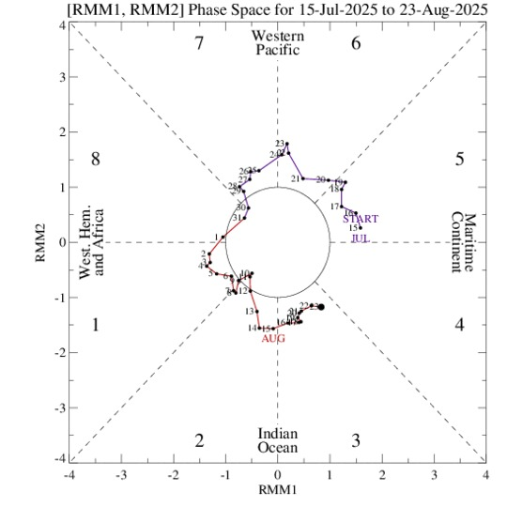
Figure 2: Current MJO position as at July 3rd Dekad, 2025

As depicted in Figure 2, the Madden-Julian Oscillation (MJO) was observed between Phases 5 and 6, corresponding to the Maritime Continent and Western Pacific regions. However, its position near the centre of the phase-space diagram indicates a weak amplitude, signifying a less active MJO signal during this period.
Given its current phase and weak intensity, the MJO was unlikely to significantly enhance convective activity over West Africa. This may have contributed to the suppression of rainfall over Ghana in the short term, as the influence of the MJO during weak phases tends to be minimal across the region.

2.0 RAINFALL, TEMPERATURE AND RELATIVE DISTRIBUTION

2.1 RAINFALL

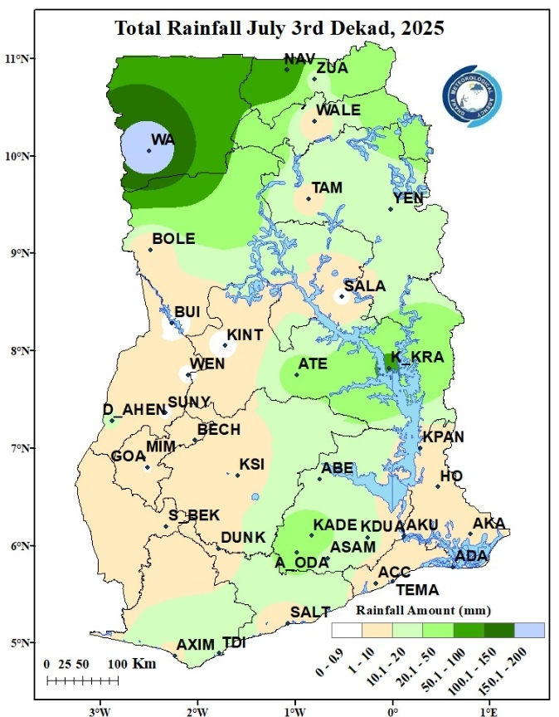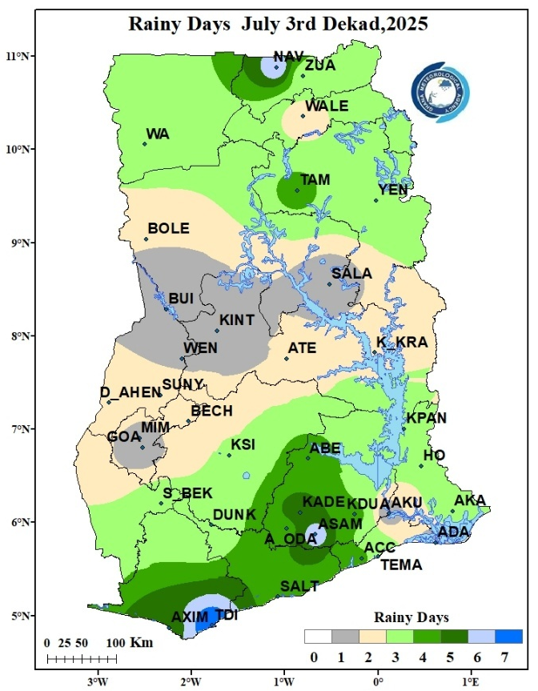
Figure 3a: Total Rainfall July 3rd Dekad, 2025
Figure 3 b: Rainy Days July 3rd Dekad, 2025
Figure 3a describes rainfall distribution across Ghana during the third ten-day period (dekad) of July. During this period, Wa recorded the highest total rainfall of 150mm. However, stations such as Navrongo, Atebubu, Kete Krachi, Kade and Akim Oda recorded rainfall amounts between 20mm and 100mm. The rest of the country recorded less than 10mm of rainfall during the dekad.
Figure 3b shows the frequency of rainy days within the same period. Stations across the transition belt and the western part of the forest belt recorded one (1) to Two (2) rainy days. The rest of the of the country recorded between three (3) to seven (7) rainy days during the dekad.
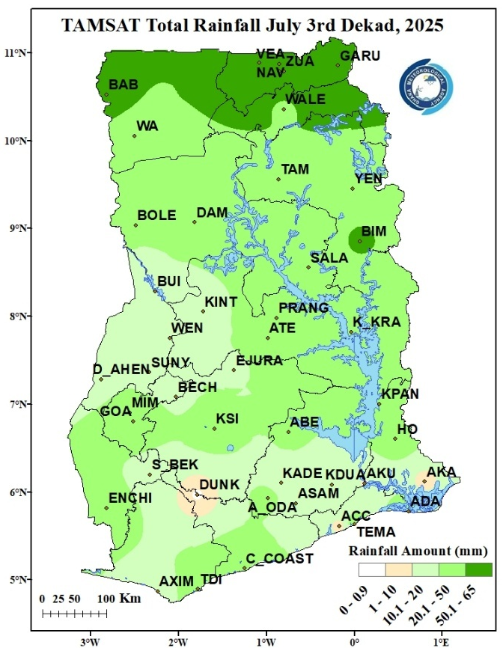
Figure 4: TAMSAT Total Rainfall July 3rd Dekad, 2025
Figure 4 represents total rainfall for the duration, as calculated from the TAMSAT rainfall estimates. The satellite-based data is helpful in terms of nationwide rainfall distribution. It can be seen from the image that the estimate for the east coast and the western portion of the transition and forest belt was above the ground observation. The rest of the country was almost in sync with the ground observation

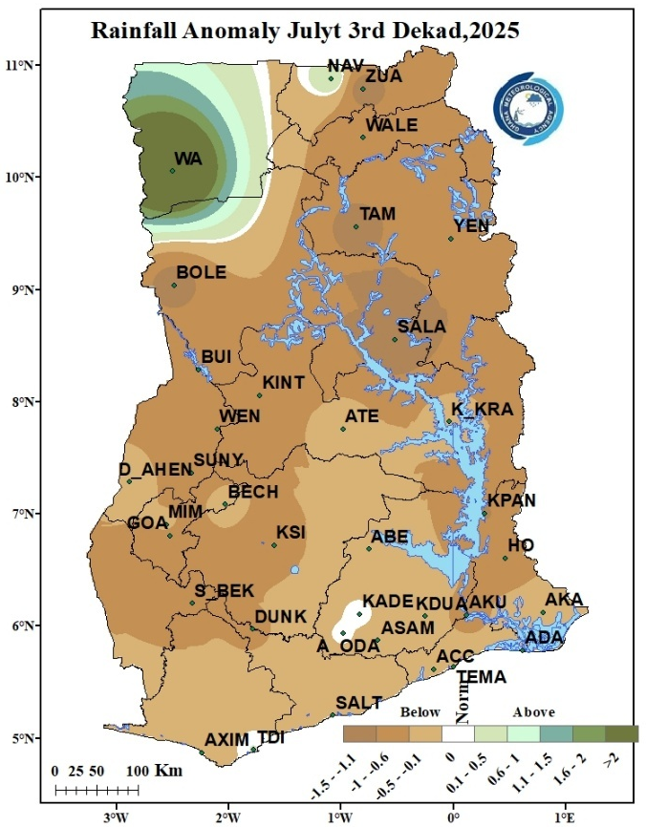
Figure 5: Rainfall Anomaly for July 3rd Dekad, 2025
Figure 5 describes areas across the country that experienced deviations from normal rainfall during the period. Notably, most stations across the country from the Northern portions through to the southern portions experienced deficit in rainfall. Stations at Akim Oda and Kade experience normal rainfall where as stations at Wa and Navrongo experienced surplus rainfall.

2.2 TEMPERATURE
Maximum Temperature
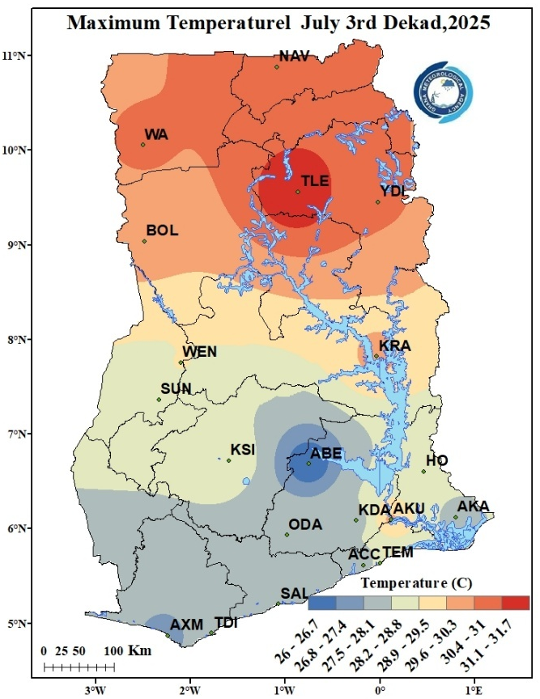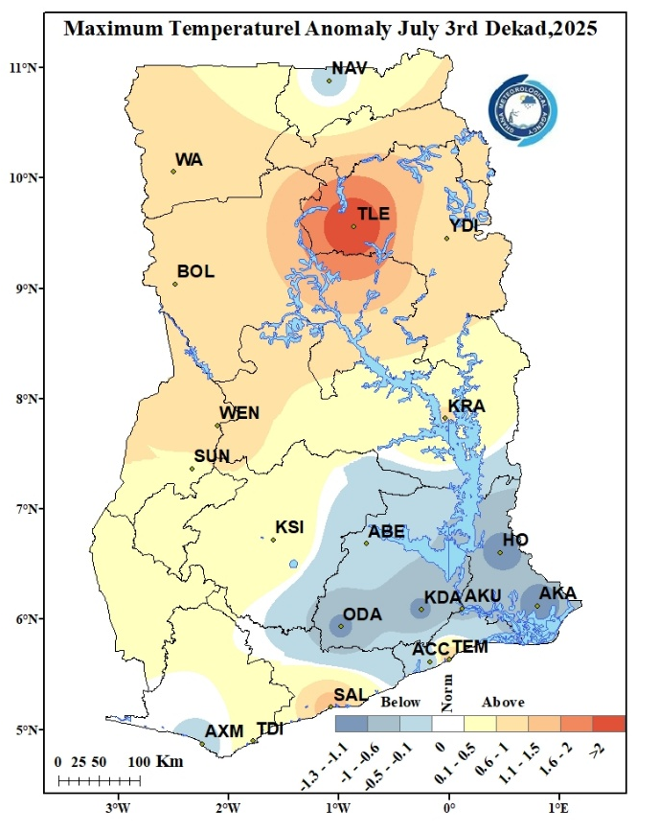
Figure 6b: Maximum Temperature Anomaly July 3rd Dekad, 2025
Figure 6a: Maximum Temperature July 3rd Dekad, 2025
Figure 6a displays the distribution of average Maximum temperatures nationwide. During the reporting period, the northern areas recorded the highest temperatures, ranging from 31.1°C to 33.0°C. The highest temperature of 31.7°C, was observed in Tamale, while the lowest, 26.0°C, was recorded in Abetifi. In the transition zone, temperatures ranged between 28.9°C and 30.3°C at places such as Wenchi and Kete Krachi. The southern sector, including locations such as Abetifi, Accra, Tema, Axim, Saltpond and Akatsi experienced relatively cooler conditions, with temperatures ranging from 26.0°C to 28.1°C. the northern belt experienced relatively warmer conditions with temperatures ranging from 29.6°C to 31.7°C.
Figure 6b illustrates the Maximum Temperature Anomalies. In this dekad, places such as Navrongo, Abetifi, Ho, Akim Oda, Accra, Koforidua, Akuse, Akatsi and Axim experienced below normal temperature. The remaining parts of the country experienced above normal temperature.

Minimum Temperature
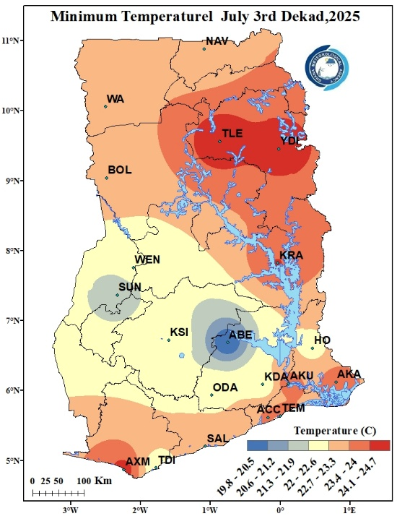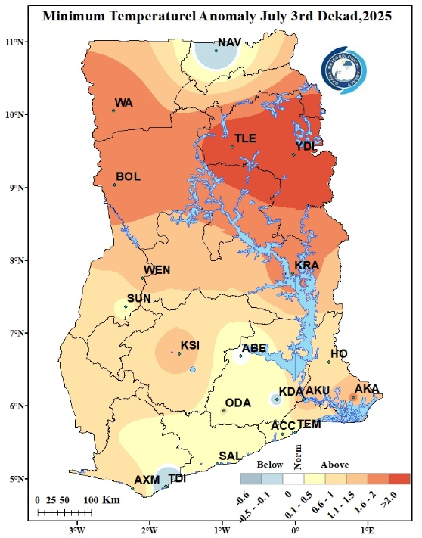
Figure 7b: Minimum Temperature Anomaly July 3rd Dekad, 2025
Figure 7a: Minimum Temperature July 3rd Dekad, 2025
In Figure 7a, the average minimum temperatures varied across different sectors. Places in and around Wa, Navrongo, Bole, Yendi, Tamale, Kete Krachi, Akuse, Axim, Saltpond, Accra, Tema and Akatsi, experienced relatively warmer conditions with temperatures ranging from 22.7°C to 24.7°C. The highest nighttime temperature recorded in the country for the period was at Ada with a temperature of 25.7°C. the rest of the country recorded relatively cooler nighttime temperatures ranging between 19.8°C and 22.6°C.
In figure 7b, we see the Minimum Temperature Anomaly for this period. Most parts of the country experienced above normal temperatures indicating increased night-time temperatures. Navrongo, Sunyani, Koforidua and Takoradi experienced below-normal temperatures where as Abetifi experienced Normal night time temperatures.
Figure 8: Max. and Min. Temperature Distribution for July 3rd Dekad, 2025
2.3 RELATIVE HUMIDITY
Observed Relative Humidity (RH) over the ten (10) day period is presented in figure 9a below. The entire country experienced Rh between 70 -90% with the exception of Bole Tamale and Yendi which recorded RH between 60 – 70%.
Average RH Anomaly is also presented in Figure 9b below. A below normal RH is observed across the entire country except for Saltpond that experienced above normal and Akuse that experienced normal RH within the period.
Figure 9a: Average Relative Humidity July 3rd Dekad, 2025
Figure 9b: Average Relative Humidity Anomaly July 3rd Dekad, 2025
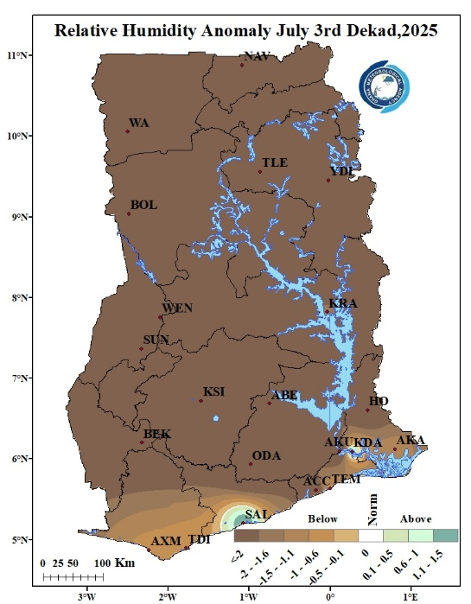
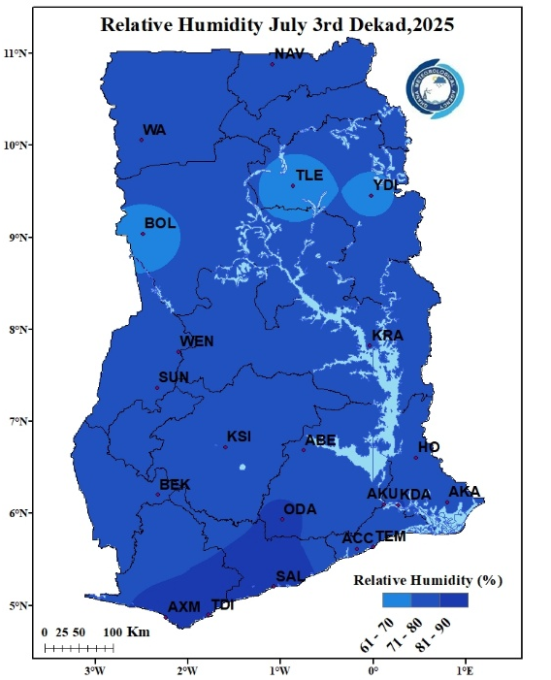

3.0 RAINFALL AND TEMPERATURE OUTLOOK 1ST- 14TH OCTOBER 2025
During Week 1, normal rainfall is expected across most parts of the country, while the western north and southeastern portions are anticipated to experience below-normal rainfall. Temperature conditions are generally expected to be below normal in most part of the country. The middle belt is expected to record above-normal temperatures whereas the extreme north and the east coast is expected to record below-normal temperatures. In Week 2, rainfall is projected to be below- normal across the southern and middle zones, with parts of the north likely to receive normal rainfall. Temperatures during this week are also expected to remain predominantly below normal over most areas of the country with the east coast having below-normal temperatures.

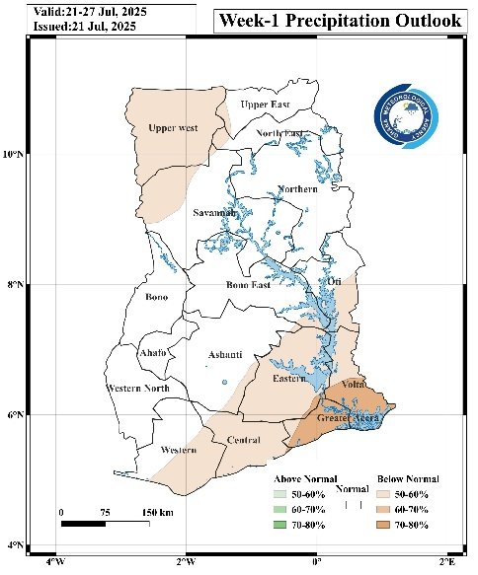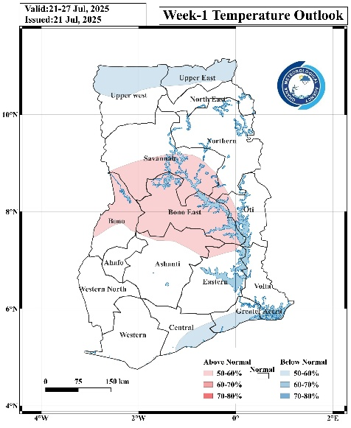

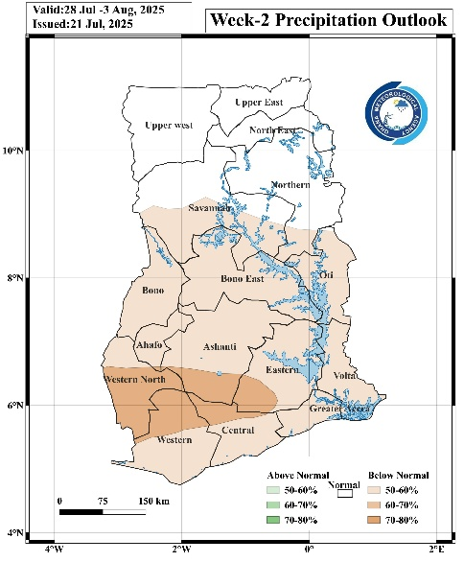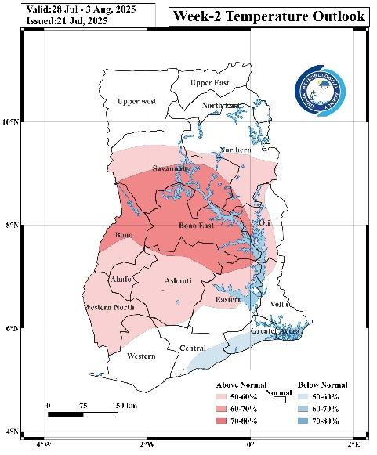

4.0 ADVISORIES

1. Agriculture
- Farmers in southern and middle zones should take advantage of the expected above-normal rainfall for planting, transplanting, and soil moisture replenishment.
- Farmers in the extreme north and southwestern areas, where below-normal rainfall is expected, should consider water-conserving practices such as mulching and avoid excessive reliance on rainfall for newly planted crops.
- Irrigation scheduling may be needed in areas expecting reduced rainfall to prevent crop stress.
2. Flood and Drainage Management
- Communities in southern and middle belts should clear drainage channels and avoid dumping waste to reduce localized flooding risks due to above-normal rainfall.
- Residents in flood-prone areas should stay alert to weather updates from the Ghana Meteorological Agency.
3. Transportation
- Motorists should exercise caution when driving when it is raining as visibility might become poor. Drivers are advised not to drive through flood waters.
4. Health
- Increased rainfall can promote mosquito breeding; communities are encouraged to clear stagnant water and use protective measures such as insecticide-treated nets.
- Cooler, below-normal temperatures may lead to respiratory infections; warm clothing is advised, especially for children and the elderly.
5. Water Resource Management
- Water managers should store and regulate water efficiently in the southern and middle belts to take advantage of increased runoff.
- In the north, prudent water use is recommended due to expected below-normal rainfall.
6. Energy / Power Sector
- Hydropower generation may benefit from increased inflows in the south and middle zones; monitoring of water levels is advised.

5.0 APPENDIX

5.1 TABLE OF STATIONS
TABLE OF STATIONS
Station | Abbreviation | Station | Abbreviation
Abetifi | ABE | Kete Krachi | K_KRA
Accra | ACC | Kade | KADE
Ada | ADA | Koforidua | KDUA
Akatsi | AKA | Kintampo | KINT
Akim Oda | A_ODA | Ho | HO
Akuse | AKU | Kpando | KPAN
Asamankese | ASAM | Kumasi | KSI
Atebubu | ATE | Mim | MIM
Axim | AXIM | Navrongo | NAV
Babile | BAB | Prang | PRANG
Bechem | BECH | Sefwi Bekwai | S_BEK
Bimbila | BIM | Salaga | SALA
Bole | BOLE | Saltpond | SALT
Bolga | BOLGA | Sunyani | SUNY
Bongo | BON | Pong Tamale | P_TAM
Bui | BUI | Tamale | TAM
Cape Coast | C_COAST | Takoradi | TDI
Damongo | DAM | Vea | VEA
Dompase | DOM | Asankragua | ASAN
Dormaa Ahenkro | D_AHEN | Tema | TEMA
Dunkwa Offin | DUNK | Wa | WA
Ejura | EJURA | Walewale | WALE
Elubo | ELUBO | Obuasi | OBU
Enchi | ENCH | Wenchi | WEN
Garu | GARU | Yendi | YEN
Goa | GOA | Zuarungu | ZUA
Half Assini | H_ASS | Assin Fosu | A_FOSU
Hunney Valley | H_VAL | Winneba | WIN
Konongo | KON | Bosomtwe | BOSOM
Mankranso | MANK | Techiman | TECH
Oti | OTI | Kajaji | KAJ

For further inquiries, clarification, information or assistance Contact:
The Director General
Tel. +233 (0)30 701 0019 or clients@meteo.gov.gh/info@met

