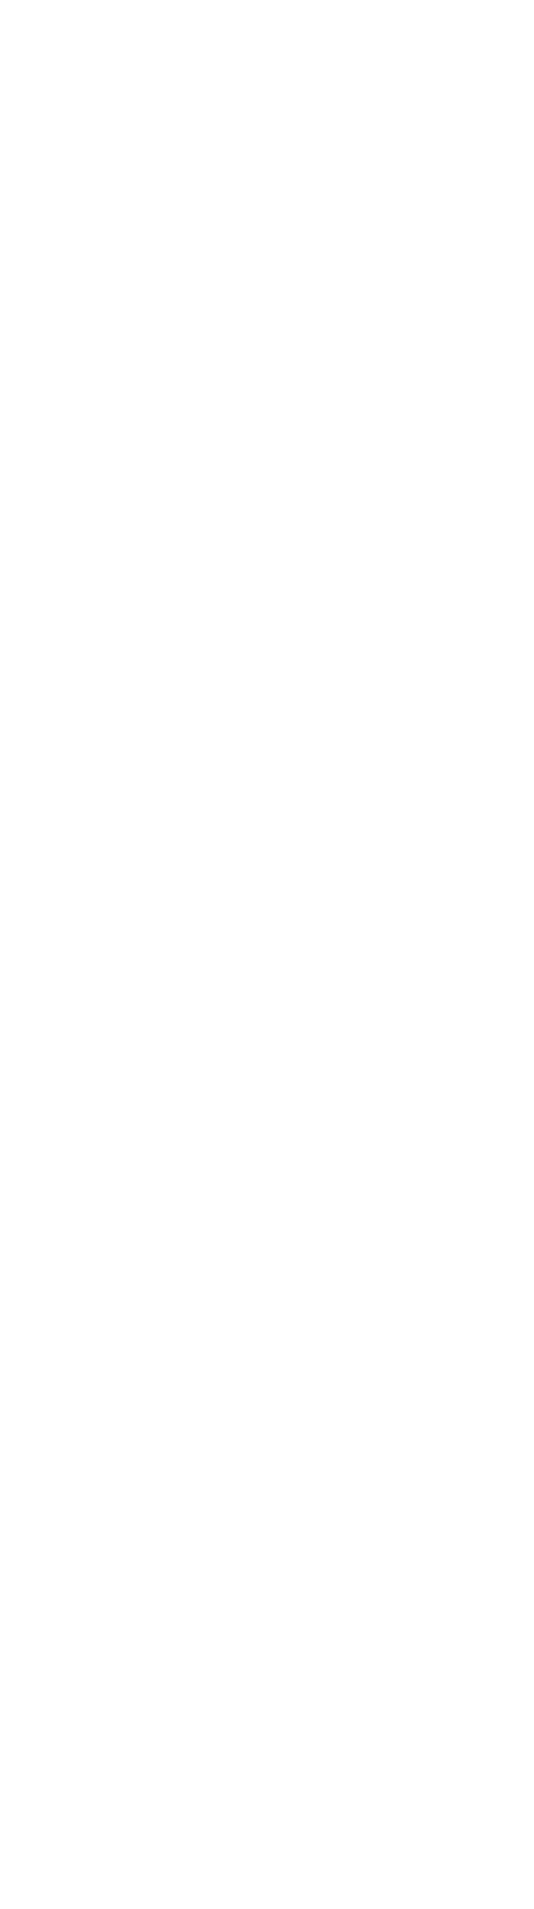
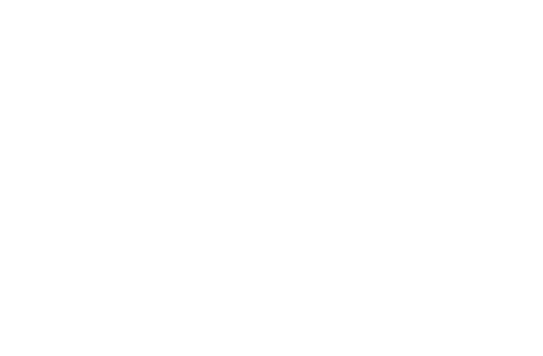
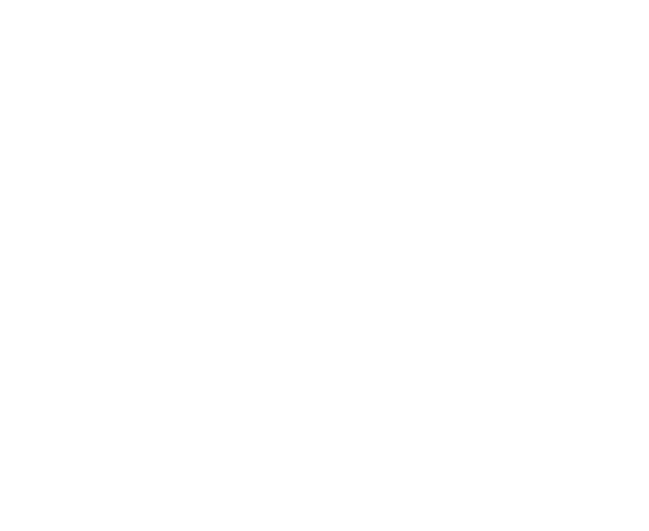
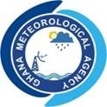

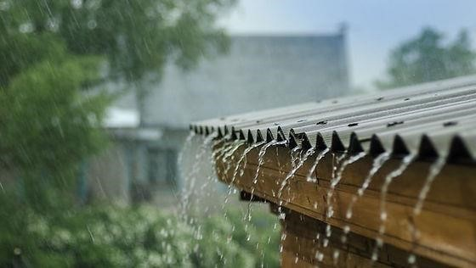

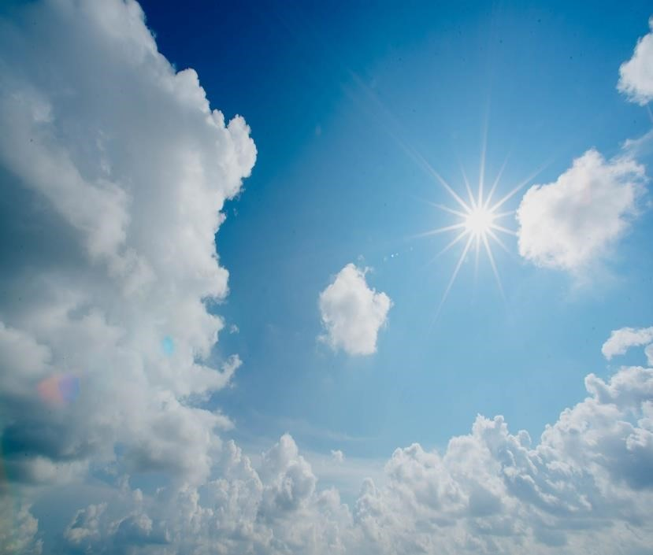

AUGUST
2025

DEKAD 3, AUGUST (21-31)

GMET/CLIMATE/0309
337
25
FORM

8/3/2025

CLIMATE BULLETIN

TABLE OF CONTENT

SUMMARY 4
1.0 OBSERVED CLIMATE DRIVERS 2
1.1 INTERTROPICAL FRONT 2
1.2 MADDEN-JULIAN OSCILLATION (MJO) 3
2.0 RAINFALL, TEMPERATURE AND RELATIVE DISTRIBUTION 5
2.1 RAINFALL 5
2.2 TEMPERATURE 7
2.3 RELATIVE HUMIDITY 10
3.0 RAINFALL AND TEMPERATURE OUTLOOK 1ST- 14TH OCTOBER 2025 11
4.0 ADVISORIES 12
5.0 APPENDIX 13
5.1 TABLE OF STATIONS 13



Website: www.meteo.gov.gh : @GhanaMet : Ghana Meteorological Agency (GMet)
Tel: 0307010019 Email: info@meteo.gov.gh ii

LIST OF FIGURES

Figure 1: Current ITF position for August 3rd Dekad, 2025 2
Table 1:Dekadal evolution of the ITF position over Ghana 2025 3
Figure 2: Current MJO position as of August 3rd Dekad, 2025 4
Figure 3a: Total Rainfall August 3rd Dekad, 2025 5
Figure 3 b: Rainy Days August 3rd Dekad, 2025 5
Figure 4: TAMSAT Total Rainfall August 3rd Dekad, 2025 6
Figure 5: Rainfall Anomaly for August 3rd Dekad, 2025 6
Figure 6a: Maximum Temperature August 3rd Dekad, 2025 7
Figure 6b: Maximum Temperature Anomaly August 3rd Dekad, 2025 7
Figure 7a: Minimum Temperature August 3rd Dekad, 2025 8
Figure 7b: Minimum Temperature Anomaly August 3rd Dekad, 2025 8
Figure 8: Max. and Min. Temperature Distribution for August 3rd Dekad, 2025 9
Figure 9a: Average Relative Humidity August 3rd Dekad, 2025 10
Figure 9b: Average Relative Humidity Anomaly August 3rd Dekad, 2025 10

iii

SUMMARY

- Rainfall:
  - Transition belt and the south received less than 20mm of rainfall.
  - Wa received the highest rainfall of 106 mm.
  - Axim recorded the highest rainy days of 7 days.
- Rainfall Anomalies:
  - deficit rainfall was recorded in most areas.
- Relative Humidity:
  - Maximum value of 74% was recorded over Saltpond
  - Minimum value of 54% was recorded over Wa.
- Temperatures:
  - Maximum:
    - Above normal temperatures experienced in most parts of the country.
    - The maximum of the Maximum temperature of 30.7°C was recorded in Akuse and Navrongo.
    - The minimum of the maximum temperature of 26.7°C was recorded in Abetifi.
    - Relatively cooler temperatures along the coast and places in the forested areas.
  - Minimum:
    - Above normal temperatures recorded across the entire country
    - Warmer temperatures in the Northern, Eastern and Coastal sector
    - The maximum of the Minimum temperature was recorded in Axim reaching 23.4°C
    - The minimum of the Minimum temperature was recorded in Abetifi, reaching 20°C.

OBSERVED CLIMATE DRIVERS

1.1 INTERTROPICAL FRONT
Also known as the Intertropical Convergence Zone (ITCZ) is a critical meteorological feature that significantly influences weather patterns in West Africa, including Ghana. The ITF is a boundary zone where the warm, moist air from the Atlantic Ocean (south westerly monsoon winds) meets the hot, dry air from the Sahara Desert (northeasterly Harmattan winds). This convergence leads to the formation of clouds and precipitation, making it a key driver of the rainy season in West Africa. The northward movement of the ITF during March-July brings the rainy season to Ghana
DEKAD | 5W | 0 | 5E
January 1 | 7.2 | 7.6 | 7.8
January 2 | 7.3 | 7.8 | 7.5
January 3 | 7.9 | 8.2 | 8.5
February 1 | 6.6 | 8.1 | 8.3
February 2 | 9.6 | 9.0 | 8.8
February 3 | 8.2 | 9.2 | 8.9
March 1 | 11.0 | 10.5 | 10.1
March 2 | 10.0 | 9.8 | 9.6
March 3 | 11.6 | 11.6 | 11.2
April 1 | 11.1 | 11.3 | 11.1
April 2 | 12.8 | 11.7 | 11.1
April 3 | 13.5 | 13.1 | 12.1
May 1 | 13.9 | 13.7 | 12.7
May 2 | 14.1 | 13.9 | 13.8
May 3 | 14.5 | 14.7 | 14.2
June 1 | 14.4 | 15.9 | 16.5
June 2 | 15.8 | 15.9 | 18.1
June 3 | 16.5 | 16.4 | 17.5
July 1 | 18.1 | 18.4 | 17.6
July 2 | 20.4 | 20.5 | 18.5
July 3 | 20.5 | 20.9 | 19.8
August 1 | 20.1 | 21.1 | 18.8
August 2 | 21 | 21.1 | 21.8
August 3 | 18.5 | 19.4 | 21.1
Table 1:Dekadal evolution of the ITF position over Ghana 2025

1.2 MADDEN-JULIAN OSCILLATION (MJO)
MJO is a tropical disturbance that moves eastward around the globe, influencing weather patterns, including rainfall and temperature, in various regions. The MJO has phases (1-8), with each phase corresponding to its location over the tropics. Its position and strength can have significant implications for weather in Ghana, particularly during the West African monsoon season.

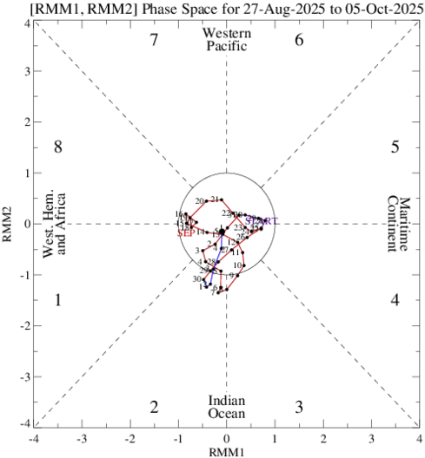
Figure 2: Current MJO position as at August 3rd Dekad, 2025

As depicted in Figure 2, the Madden-Julian Oscillation (MJO) was observed between Phases 5 and 6, corresponding to the Maritime Continent and Western Pacific regions. However, its position near the centre of the phase-space diagram indicates a weak amplitude, signifying a less active MJO signal during this period.
Given its current phase and weak intensity, the MJO was unlikely to significantly enhance convective activity over West Africa. This may have contributed to the suppression of rainfall over Ghana in the short term, as the influence of the MJO during weak phases tends to be minimal across the region.

2.0 RAINFALL, TEMPERATURE AND RELATIVE DISTRIBUTION

2.1 RAINFALL
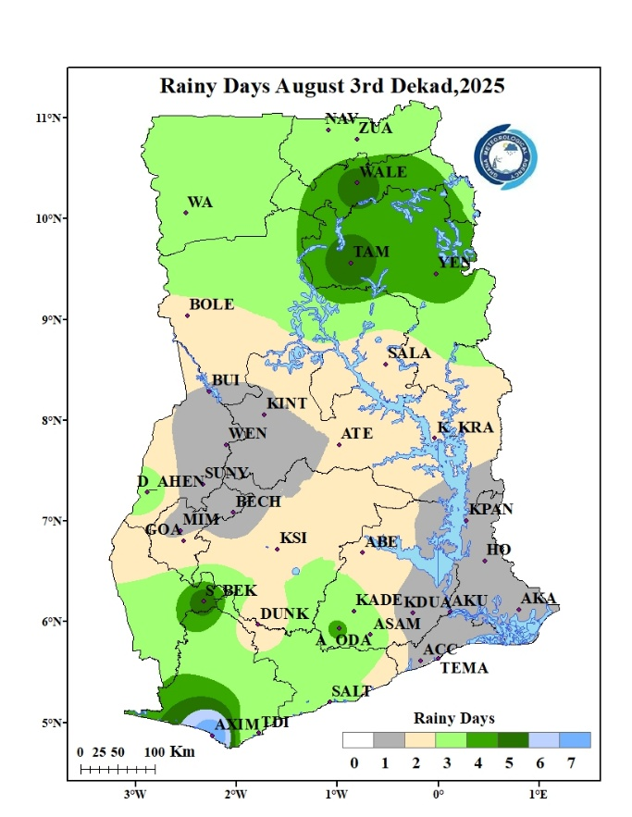
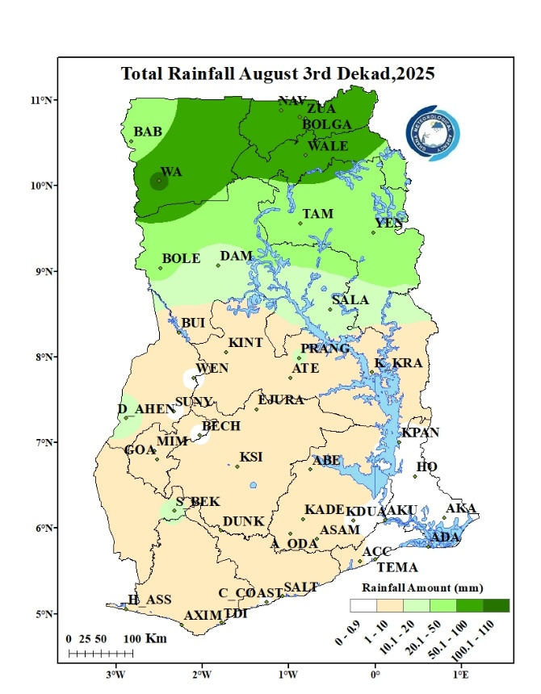

Figure 3a: Total Rainfall August 3rd Dekad, 2025
Figure 3 b: Rainy Days August 3rd Dekad, 2025
Figure 3a describes rainfall distribution across Ghana during the third ten-day period (dekad) of August. During this period, Wa recorded the highest total rainfall of 106mm. the entire northern portion of the country recorded above 10mm. the tr ansition belt through to the forest and coastal zone recorded less than 10mm of rainfall except stations like Prang Dormaa Ahenkro and Sefwi Bekwai. The extreme southeastern part of the country did not record any rainfall.
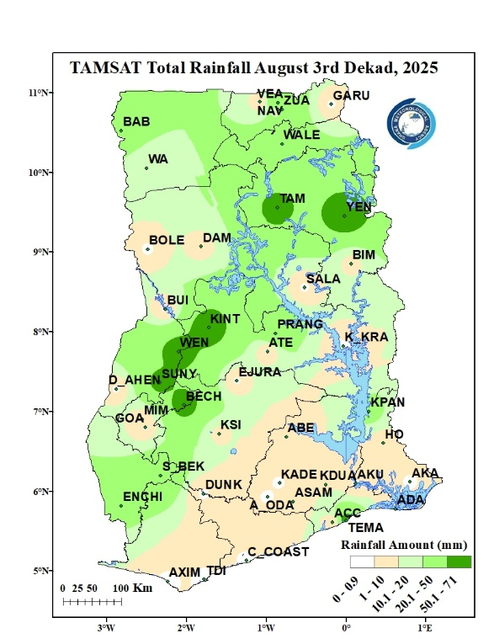
Figure 3b shows the frequency of rainy days within the same period. The North and the extreme southeast recorded three (3) to four (4) rainy days with Axim recording the highest of seven (7) rainy days during the dekad. The rest of the country recorded two (2) rainy days or less.
Figure 4 represents total rainfall for the duration, as calculated from the TAMSAT rainfall estimates. The satellite-based data is helpful in terms of nationwide rainfall distribution. It can be seen from the image that the TAMSAT generally reproduced the ground-based observations

Figure 4: TAMSAT Total Rainfall August 3rd Dekad, 2025

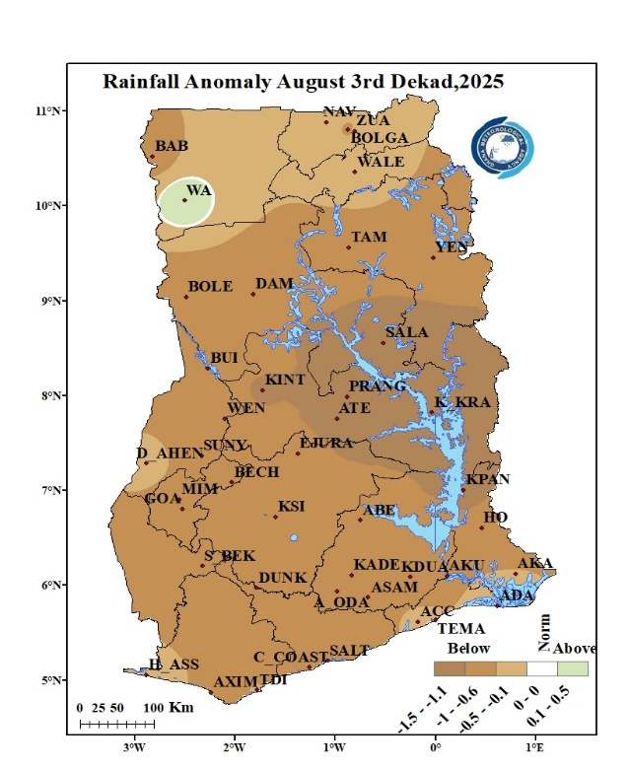
Figure 5 describes areas across the country that experienced deviations from normal rainfall during the period. The entire country experienced below normal rainfall with the exception of Wa that experienced above normal rainfall during the period.

Figure 5: Rainfall Anomaly for August 3rd Dekad, 2025

2.2 TEMPERATURE
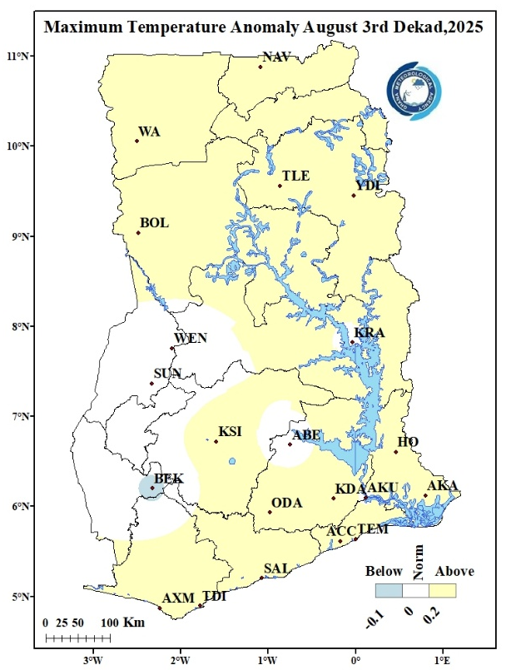
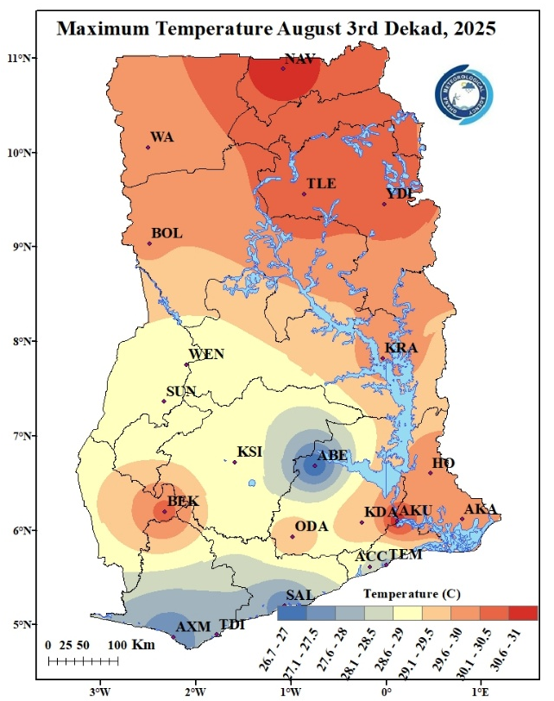
Maximum Temperature
Figure 6b: Maximum Temperature Anomaly August 3rd Dekad, 2025
Figure 6a: Maximum Temperature August 3rd Dekad, 2025
Figure 6a displays the distribution of average Maximum temperatures nationwide. During the reporting period, the northern areas, transition and the easternmost parts of the country recorded the highest temperatures, ranging from 29.1°C to 31.0°C. The highest temperature of 30.6°C, was observed in Navrongo, while the lowest, 26.7°C, was recorded in Abetifi. The southern sector, including locations such as Abetifi, Accra, Axim, Takoradi, Saltpond and Tema experienced relatively cooler conditions, with temperatures ranging from 26.7°C to 28.5°C.
Figure 6b illustrates the Maximum Temperature Anomalies. In this dekad, places such as Wenchi, Abetifi, Kete Krachi, Akuse and Sunyani experienced normal day time temperature. Below normal temperature conditions were experienced in Sefwi Bekwai whereas the remaining parts of the country experienced above normal temperature.

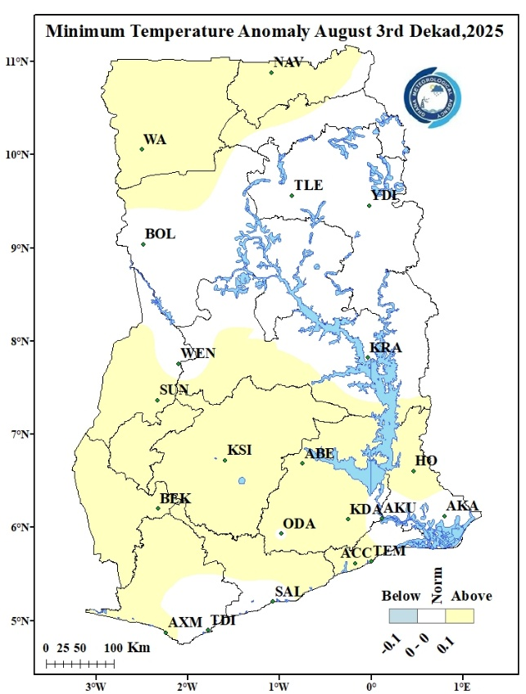
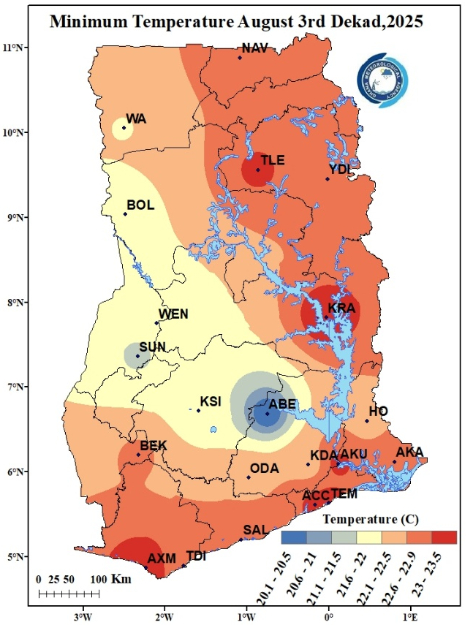
Minimum Temperature
Figure 7b: Minimum Temperature Anomaly August 3rd Dekad, 2025
Figure 7a: Minimum Temperature August 3rd Dekad, 2025

In Figure 7a, the average minimum temperatures were relatively warmer across most places. Places such as Wa, Bole, Wenchi, Sunyani, Kumasi and Abetifi experienced relatively cooler nighttime temperatures ranging from 20°C to 22°C. the rest of the country experienced relatively warmer conditions with temperatures ranging from 22.1°C to 23.5°C. The highest nighttime temperature recorded in the country for the period was at Axim with a temperature of 23.5°C. The lowest nighttime temperature during the period was recorded at Abetifi with a temperature of 20°C.
In figure 7b, we see the Minimum Temperature Anomaly for this period. Most parts of the northern portion of the country and the entire forest belt experienced above normal temperatures indicating increased night-time temperatures. The transition belt and areas like Bole, Tamale and Yendi in the north and Takoradi, Saltpond, Akuse and Akatsi in the south experienced normal temperatures.

Figure 8: Max. and Min. Temperature Distribution for August 3rd Dekad, 2025

2.3 RELATIVE HUMIDITY
Observed Relative Humidity (RH) over the ten (10) day period is presented in figure 9a below. The forest, most parts of the coastal areas and Navrongo and Tamale in the north experienced RH of 60 to 80%. On the other hand, the Transition, the rest of the Northern areas and the the extreme eastern portion of the country experienced RH values ranging from 50 to 60 %. A minimum value of 54% was recorded over Wa while a maximum value of 74% was recorded over Saltpond.
Average RH Anomaly is also presented in Figure 9b below. A below normal RH is observed across the entire country.
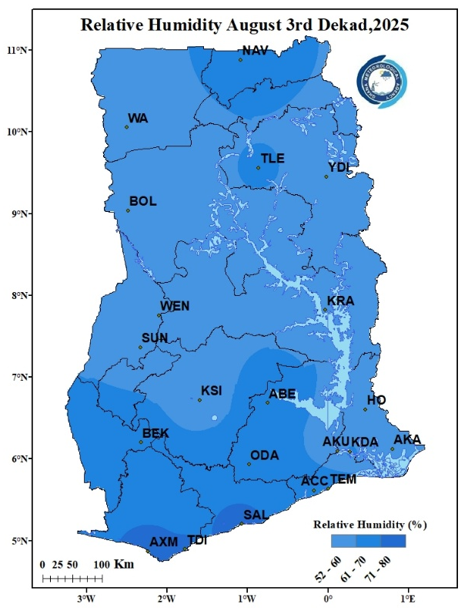
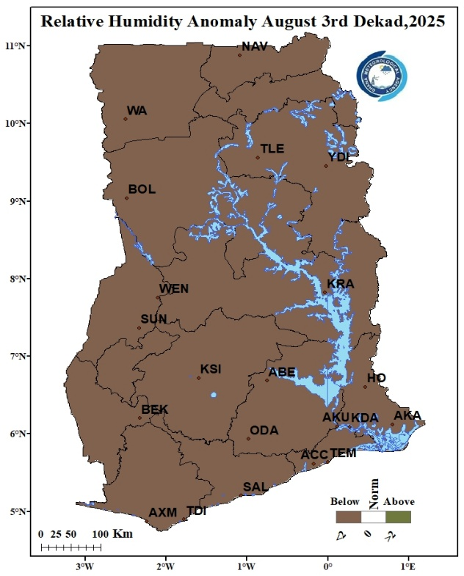
Figure 9a: Average Relative Humidity August 3rd Dekad, 2025
Figure 9b: Average Relative Humidity Anomaly August 3rd Dekad, 2025

3.0 RAINFALL AND TEMPERATURE OUTLOOK 1ST- 14TH OCTOBER 2025

During Week 1, above-normal rainfall is expected across most parts of the country, while the extreme northern and southwestern portions are anticipated to experience below-normal rainfall. Temperature conditions are generally expected to be below normal nationwide, although a few locations within the middle belt may record slightly above-normal temperatures. In Week 2, rainfall is projected to be above- normal across the southern and middle zones, with parts of the north likely to receive below-normal rainfall. Temperatures during this week are also expected to remain predominantly below normal over most areas of the country.
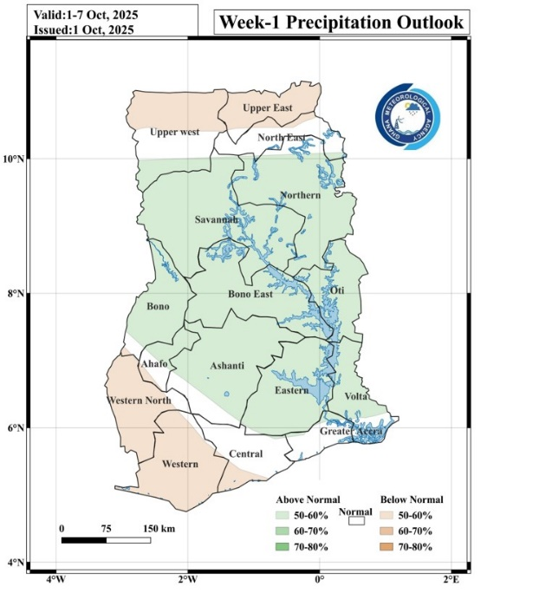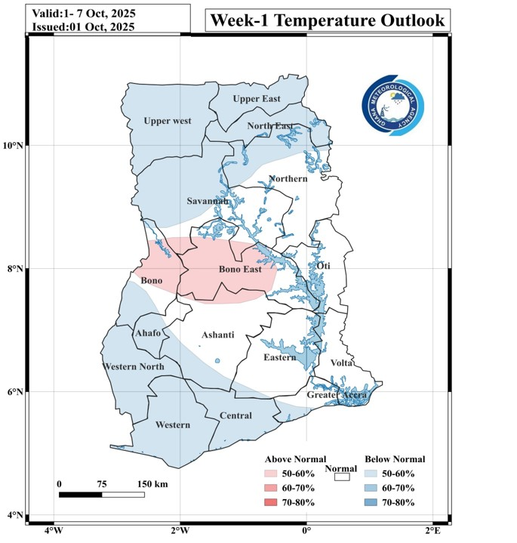

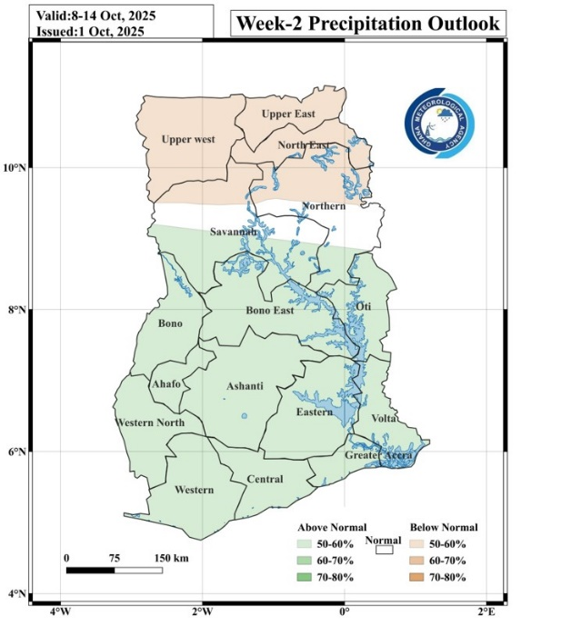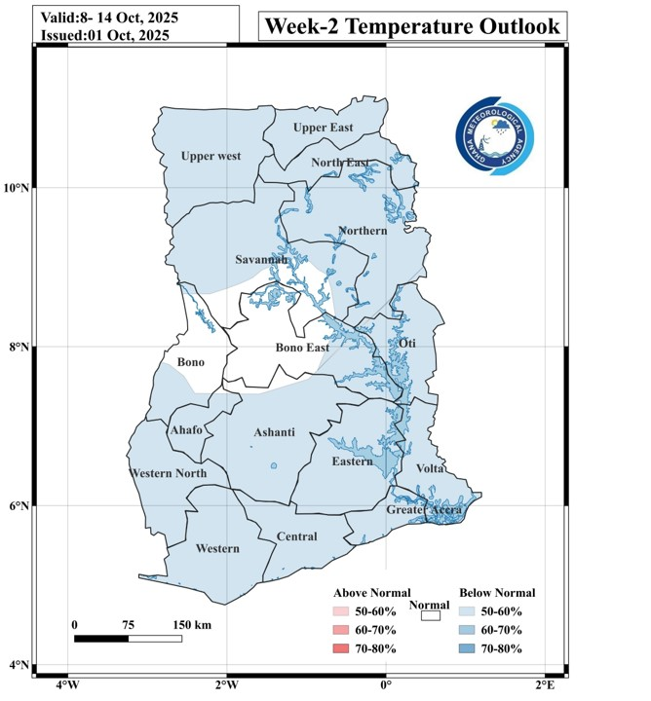

4.0 ADVISORIES

1. Agriculture
- Farmers in southern and middle zones should take advantage of the expected above-normal rainfall for planting, transplanting, and soil moisture replenishment.
- Farmers in the extreme north and southwestern areas, where below-normal rainfall is expected, should consider water-conserving practices such as mulching and avoid excessive reliance on rainfall for newly planted crops.
- Irrigation scheduling may be needed in areas expecting reduced rainfall to prevent crop stress.
2. Flood and Drainage Management
- Communities in southern and middle belts should clear drainage channels and avoid dumping waste to reduce localized flooding risks due to above-normal rainfall.
- Residents in flood-prone areas should stay alert to weather updates from the Ghana Meteorological Agency.
3. Transportation
- Motorists should exercise caution when driving when it is raining as visibility might become poor. Drivers are advised not to drive through flood waters.
4. Health
- Increased rainfall can promote mosquito breeding; communities are encouraged to clear stagnant water and use protective measures such as insecticide-treated nets.
- Cooler, below-normal temperatures may lead to respiratory infections; warm clothing is advised, especially for children and the elderly.
5. Water Resource Management
- Water managers should store and regulate water efficiently in the southern and middle belts to take advantage of increased runoff.
- In the north, prudent water use is recommended due to expected below-normal rainfall.
6. Energy / Power Sector
- Hydropower generation may benefit from increased inflows in the south and middle zones; monitoring of water levels is advised.

5.0 APPENDIX

5.1 TABLE OF STATIONS
TABLE OF STATIONS
Station | Abbreviation | Station | Abbreviation
Abetifi | ABE | Kete Krachi | K_KRA
Accra | ACC | Kade | KADE
Ada | ADA | Koforidua | KDUA
Akatsi | AKA | Kintampo | KINT
Akim Oda | A_ODA | Ho | HO
Akuse | AKU | Kpando | KPAN
Asamankese | ASAM | Kumasi | KSI
Atebubu | ATE | Mim | MIM
Axim | AXIM | Navrongo | NAV
Babile | BAB | Prang | PRANG
Bechem | BECH | Sefwi Bekwai | S_BEK
Bimbila | BIM | Salaga | SALA
Bole | BOLE | Saltpond | SALT
Bolga | BOLGA | Sunyani | SUNY
Bongo | BON | Pong Tamale | P_TAM
Bui | BUI | Tamale | TAM
Cape Coast | C_COAST | Takoradi | TDI
Damongo | DAM | Vea | VEA
Dompase | DOM | Asankragua | ASAN
Dormaa Ahenkro | D_AHEN | Tema | TEMA
Dunkwa Offin | DUNK | Wa | WA
Ejura | EJURA | Walewale | WALE
Elubo | ELUBO | Obuasi | OBU
Enchi | ENCH | Wenchi | WEN
Garu | GARU | Yendi | YEN
Goa | GOA | Zuarungu | ZUA
Half Assini | H_ASS | Assin Fosu | A_FOSU
Hunney Valley | H_VAL | Winneba | WIN
Konongo | KON | Bosomtwe | BOSOM
Mankranso | MANK | Techiman | TECH
Oti | OTI | Kajaji | KAJ

For further inquiries, clarification, information or assistance Contact:
The Director General
Tel. +233 (0)30 701 0019 or clients@meteo.gov.gh/info@met

